 Programming - 21.10.2022 - 6 Credits

Conceptual Design - 21.10.2022 - 6 Credits

Prototyping - 21.10.2022 - 6 Credits

External Report - 21.10.2022 - 3 Credits

Computer Science   
Documentation

___

Jordan Heron

Title Page: Introduction

*This document consists of all of the computer science documentation for every standard.*

2.6 Programming

Jordan Heron

30.9.2022

Project Brief: Requirements

This Assessment activity requires you to plan. trial, test and develop a computer program using advanced programming techniques. You will use a development process to help you make informed decisions throughout the coding, testing, and trailing of your program and show ongoing refinement to improve the functionality and quality of your program.

You will be assessed on how effectively you plan your development, decompose the outcome into smaller components, and test and refine your program so that it is a high-quality response to the task (e.g., well-structured, logical, flexible, robust, and comprehensively tested).

When planning and developing your program, you must ensure your program:

●        uses variables storing [at least two types of data](https://www.geeksforgeeks.org/python-variables/) (e.g., numeric, text, Boolean)

●        uses sequence, [selection](https://www.geeksforgeeks.org/python-if-else/) and [iteration](https://www.geeksforgeeks.org/loops-in-python/) control structures

●        takes input from a user, sensor(s), or other external source(s)

●        produces output

AND includes two or more advanced programming techniques, such as writing code that:

●        modifies data stored in collections (e.g. [lists](https://www.geeksforgeeks.org/python-list/), [arrays](https://www.geeksforgeeks.org/array-python-set-1-introduction-functions/), [dictionaries](https://www.geeksforgeeks.org/python-set-4-dictionary-keywords-python/))

●        defines and manipulates multidimensional data in collections

●        creates methods, [functions](https://www.geeksforgeeks.org/python-user-defined-functions/), or procedures that use parameters and/or return values

●        responds to events generated by a graphical user interface (GUI)

●        requires non-basic string manipulation

●        uses functionality of additional non-core libraries.

●        Reading data from external sources

Application Pitch: Brief

My application is going to be a budget laptop calculator to assist students and their parents when

purchasing a laptop for school usage. It will have 4 input areas yet to be decided which the user will

select what they want out of their laptop and then the program will output an estimated cost.

Planning Tools: Notion

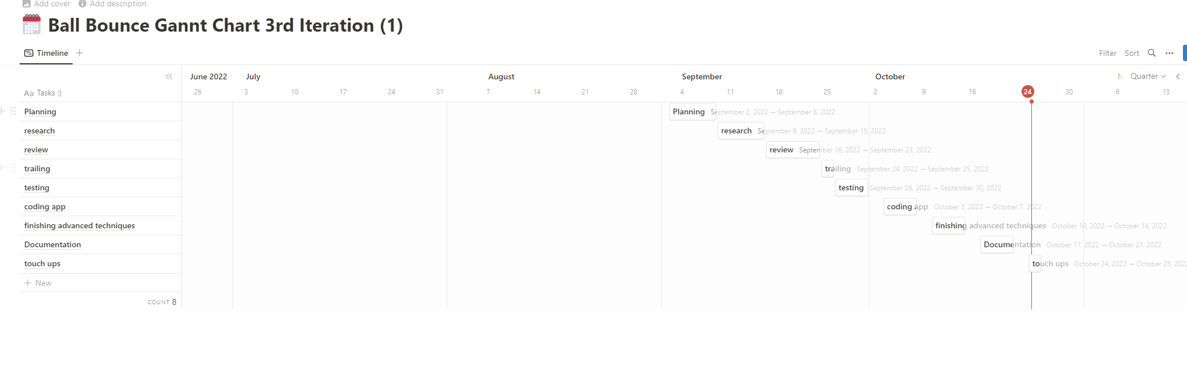

I used the project management site called notion and I used it in the form of a Gannt chart to keep myself on track. I used the list created in the decomposition stage and put it into a timeline so now each task has its own time parameters which makes it easier to manage my time and stay on top of things. These planning techniques allowed me to properly plan the development of my task.

Software Testing: Research

|  |  |  |
| --- | --- | --- |
| Name: | Description: | Uses: |
| Panda | Panda is built for python and is an open-source data analysis and manipulation tool. It provides support for multi-dimensional arrays and is built on another package named NumPy. Panda is great for anything data science which is great because it's very easily implementable to my code. | Data cleansing, Data fill, Data normalization, Merges and joins, Data visualization, Statistical analysis, Data inspection, Loading and saving data |
| Pygame | Pygame is a set of python modules designed for writing video games. Pygame adds a really good SDL library. Pygame is highly portable and runs on nearly every platform. It is great for my code as it can be used to create the interface. | Game UI  Pygame Docs |
| Tensor Flow | Tensor flow is used for machine learning and data analysis. It has easy model building, robust ML production and powerful experimental research. This would be really good to use to increase the sustainability of the code, but it is very hard to learn and implement so I might not use it in my code. | Machine learning  Data analysis |
| Tkinter | Tkinter is the de facto way to create GUIs in python and is the only program built into the python framework. Tkinter is quite complex with a lot of different applications meaning you can do a lot with it. | GUI creation |

Review:

After my planning and research was done

Decomposition: List

Tasks:

* Planning
* Research
* Review
* Trailing
* Testing
* Adapting from testing
* Finish up
* Documentation
* Touch ups

Component 1:

*Interface*

* *Wireframe designs*
* *Implement pygame pip install in vs code*
* *Create of application*
* *Create application outline*
* *Create Heading*
* *Create the 4 exponents as their inputs (search bar, button or multichoice)*
* *Create output of predicted price*

Component 2:

*Panda*

* *Implement panda pip install in vs code*
* *Remove any unnecessary data from the main csv file along with shortening it to a chosen size*
* *Create 4 csv files with all the different inputs data in them*
* *Create a search function that removes any of the pieces of data that aren’t searched for*
* *Create an average*
* *Create an output for this average*

Component 3:

*Touch Ups*

* *Link the output of the searched file into the output function create with pygame*

Test and Trailing:

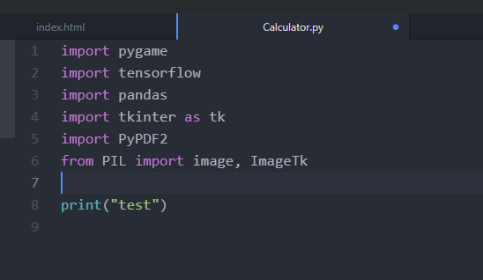

This is a photo of me testing that I could actually import each library without any complications which proved to be successful as if I couldn’t I’d just move on from that program.

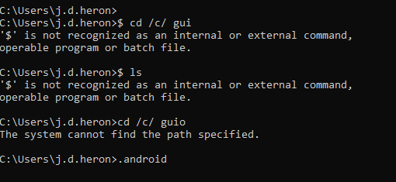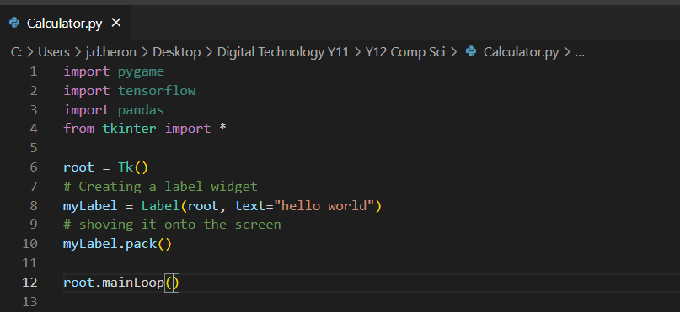

I had to watch multiple tutorials on how to create a GUI so I could get started, the first tutorial I watched didn’t work as they had too many of their own programs so when I watched the next one when they were on atom instead of visual studio, I made the switch. I also had to install anaconda as the tutorial was using this instead of command prompt and when I tried command prompt it didn’t work. After all of this I watched a tutorial that used pygame and after following it for a while I was able to create a base GUI.

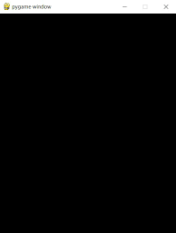

After this was created, I decided I would map out the rest of the application with pygame, so I created a design theme and multiple buttons with a dropdown menu, text inputs and buttons that when pressed send confirmation to the console. They also change colour when hovered over.

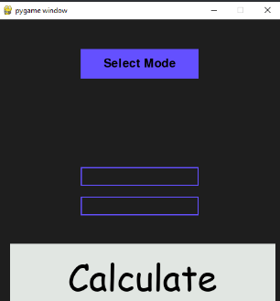

Relevant Implications: Future Proofing

Aesthetic:

The aesthetic of the GUI interface is a small box with a dark grey background and purple and white colour changing buttons with black text. The design is meant to be compact like a normal calculator application would be. It also has some interactive feedback as the white boxes change colour to purple and the purple turn a darker shade to notify when they have been clicked/hovered over.



The end-users are probably people with a lot of computer experience meaning the text can be smaller and it can a slightly more complex design as there is less instructions to navigate it. The aesthetic of purple and black is also made to reflect the theme of most people’s computers if they spend a lot of time on them.

Future Proofing:

I used GitHub as a way to monitor my version controls and also to safely backup my files, so they don’t get corrupted. The different files I need to save are only the different versions so there are no big files or assets that need saving. GitHub also lets others access my code and use the program for themselves. All of the things I have used being pygame, Visual Studio Code and GitHub are websites or programs that have a long future and will probably expand even more so there is no threat of any of these tools being disconnected.

Legal:

I do have the right in using all my tools being GitHub, pygame and Visual studio code as what I am doing with them is what they were designed to do. Creating a calculator comes under creative commons as other people probably would have done the same but I have directly or intentionally copied their code and tried to pass it of as my own. Even If I have it still wouldn’t be a legal violation an ethics violation maybe but not a legal one. I avoided copyright by coding the calculator myself and the view tutorials I did watch I had to change the code up anyway also tutorials encourage copying their code as that’s their whole purpose. I haven’t used any images or textures in my program so there is no legal threat on that side. I haven’t made any reference as nothing I used is deemed referenceable.

End User considerations:

The importance of the program from the client’s point of view is how many variables it can take and how accurate it is. For the variables I have 3 which should be enough and for the accuracy it should be 100% as its pulling from a list of actual prices. The client’s goal for using the program would be to calculate the price of a computer with specific variables. The documentation of this project is also on GitHub which is where the users would go to use it so they can use this as a directory for its function. I haven’t tried to make it accessible to anyone outside of the English-speaking community as they would be a part of my clientele. It is also accessible on phones and will behave the exact same way as the size is set and is small enough to be functional on the phone.

Social:

The clients wants to be able to calculate the price of a computer with a set of variables they have chosen. The website is very functional as there is only every function on the website in there meaning every button directly contributes to the functionality of the task of the website. I believe the design is suited for this type of audience as it would be people who spend a lot of time on the computer, so I have made it functionally and aesthetically match with these clients needs. It is viewable and useable online through GitHub where users can also see the code and this document.

Reflection: Summary

* *discussing how the information from planning, testing, and trialling of components assisted in the development of a high-quality outcome*

Version: Code Iterations

* effectively using project management and version control tools and techniques to manage the development of a digital technology’s outcome

**Achieved**: Use *advanced processes* to develop a digital technologies outcome.

* using appropriate project management tools and techniques to plan the development of a digital technology’s outcome
* decomposing the outcome into smaller components
* trialling the components of the digital technology’s outcome
* testing that the digital technologies outcome functions as intended
* explaining relevant implications

and at least two of:

* saving back-up copies with a logical file naming system
* using collaboration tools
* using simple version control software applications
* using tools or systems to plan tasks and milestones
* adjusting key actions and tasks where appropriate

Merit: Use advanced processes to develop an *informed* digital technologies outcome.

* effectively using project management and version control tools and techniques to manage the development of a digital technology’s outcome
* trialling multiple components and/or techniques and selecting those which are most suitable
* using information appropriately from testing and trialling to improve the functionality of the digital technology’s outcome
* addressing relevant implications

Excellence: Use advanced processes to develop a *refined*digital technologies outcome.

* discussing how the information from planning, testing, and trialling of components assisted in the development of a high-quality outcome

2.3 Conceptual Design

Jordan Heron

30.9.2022

*Replacement for planning standard*

Conceptual Design: 91356

-          Brief

        Develop a conceptual design for an outcome involves:

*·         Establishing potential conceptual designs through generating and evaluating design ideas that are informed by research, including the analysis of existing outcomes*

*·         Using evidence from research and functional modelling, including feedback from stakeholders, to evaluate conceptual designs*

*·         Selecting and communicating the final conceptual design for an outcome*

*·         Explaining the outcome’s potential fitness for purpose.*

Develop a refined conceptual design for an outcome involves:

*·         Ongoing exploration and evaluation of design ideas to determine their suitability for inclusion in conceptual designs*

*·         Using evidence from ongoing research and functional modelling, including feedback from stakeholders, to evaluate conceptual designs.*

Develop a justified conceptual design for an outcome involves:

*·         Synthesizing evidence from ongoing research and functional modelling, including feedback from stakeholders, to evaluate conceptual designs*

*·         Substantiating the outcome’s potential fitness for purpose.*

- Client

*I’ve chosen to create a website for a student at Saint Kentigern college who is looking to create a website for tutoring and education. I will closely work with him going through multiple iterations to be able to create the best design possible.*

- Client Brief

*The brief is to create a site that users can create an account on and function like education perfect where they can answer questions and complete quizzes but also to be able to purchase and book tutors. He wanted the design to be simplistic and have a clear color palette, he didn’t really mind what colours they were but he said to create the site so it’s ‘bubbly’ so it feels more welcoming to users.*

Research: Existing Examples

-          Education Perfect:

[*https://www.educationperfect.com/*](https://www.educationperfect.com/) *: Education Perfect is a site that allows teachers to set questions and tasks for students which also tracks how much they have done and compares it to other students. It is also capable of holding assessments for online learning as existing the tab will send a warning to the teacher.*

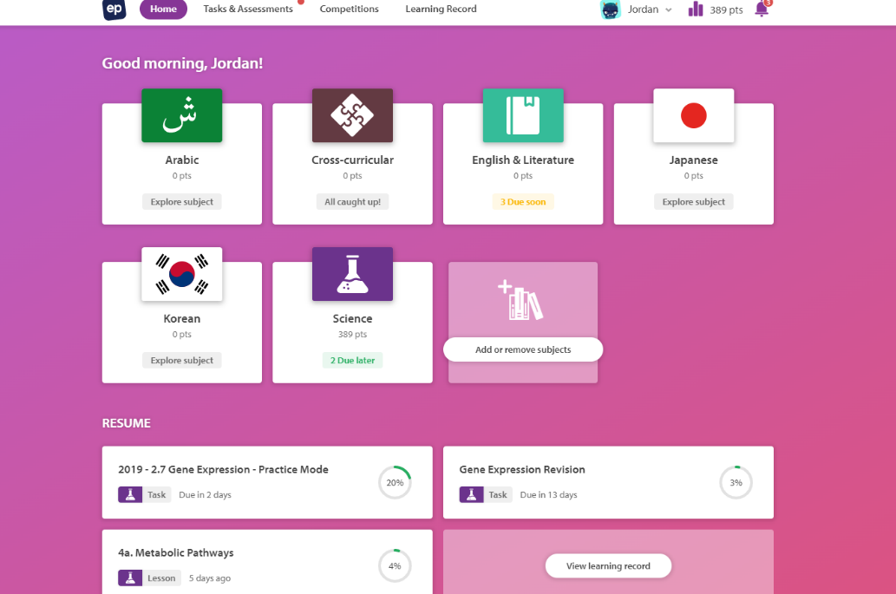

-          Duolingo:

[*https://www.duolingo.com/learn*](https://www.duolingo.com/learn) *: Duolingo is heavily language focused but still has the same principles as an education site. It is also a lot more Individual learning based as there are no teachers, it is just goals set by the students.*

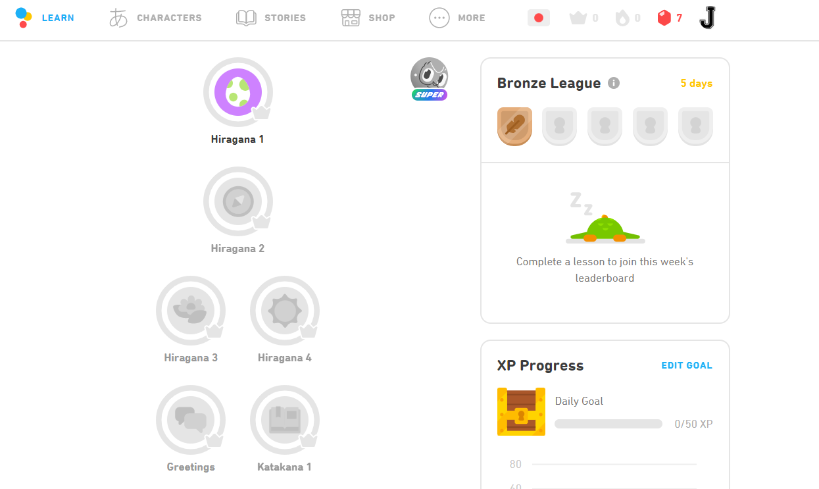

-          Khan Academy:

[*https://www.khanacademy.org/*](https://www.khanacademy.org/) *:  Khan Academy is a very big site that can be teacher focused like education perfect with classes with work that can be set by teachers, but it can also encompass individual learning as it has a lot of tools like videos and quizzes for students to do alone.*

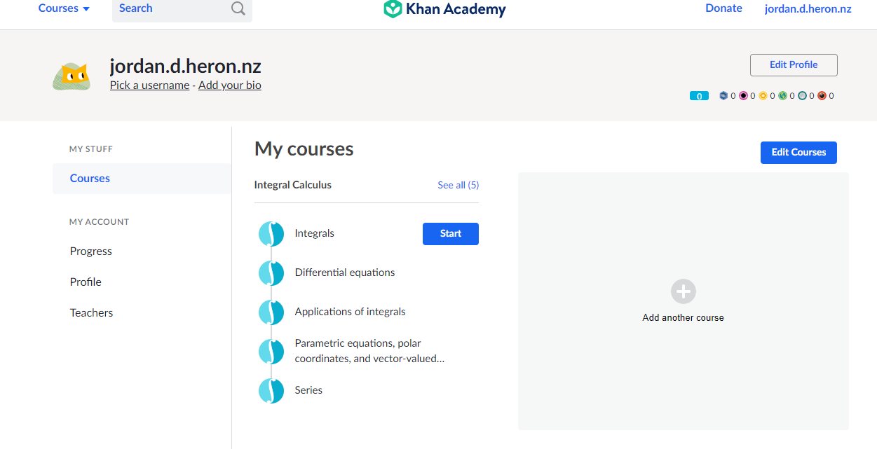

Social Investigation: Environment

-          Durability

*This website idea is pretty safe from being outgrown as the future is digital schooling, the area this website is in has a lot of survivability and along with survivability the other parts of durability such as the website staying up really depends on the host and how many users there are but it doesn't require too much to run.*

-          Target market (age)

*The target market is obviously high school students but it can also be used by anyone looking at something which might be a little harder for them as it is designed for students doing NCEA so it will be in that format, but it can still be utilized. It is also hyper-specialized for SKC students but is highly recommended for other students as well.*

-          Environment

*The field/environment this website is trying to compete in is the educational area but also a transactional side as the idea for the website is being able to book tutors.*

-          Theme (colour)

*Most websites research offered a simple white colour scheme and they sometimes have a different coloured background with white as a secondary colour. Then for 3rd colours it's usually a variety of different brightly coloured buttons.*

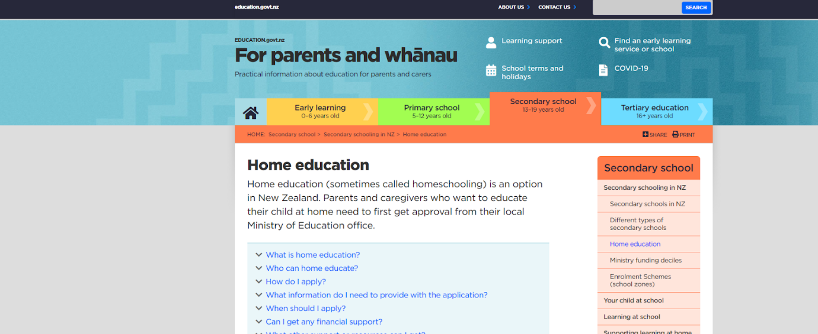

Issue/potential: Opportunity

-          Decision

*The top 3 issues for this website are the workload, environment, and theme. I chose workload because for a website like this there are a lot of things to do and things to get caught up on and a lot of expectations to manage. I chose environment because the environment for online education is very competitive, and it would be hard to get users with so many good already existing outcomes. Lastly, I chose the theme because this is very important for the website to stand out and a lot of things need to be done about it to refine it and get it to its fullest potential.*

-          Action Play

*My solution for the workload is to have another person working on the website with me so the workload is halved, and I also had to pull back the expectations for the website the client had. To fix the problem with the competition or environment I decided to specialize very heavily for Saint Kentigern students as reducing the target market leaves opportunities for them to still use the other sites but also ours as well because it's more tailored to them and each has their own ups and downs. For the theme there will be a lot of back and forth between the client and us to get the image right meaning there will be multiple concepts and other things in order to refine this idea.*

-          Client/stakeholder discussion on environment context

*I presented the ideas I had to the client about what to do to lessen the environment reach or competition which he seemed to have loved and he brought up the point that the more uses we have like booking tutoring and being an educational website, the more users will be pulled as it’s tailored to more of their needs than just one so there is more things they can do with the website.*

Research: Concepts

-          What did I like

*Education perfects concept is to create a virtual learning environment through set tasks by teachers and class competition. Education works really well for memorisation as its format fits it perfectly as the questions and the way you answer them are really helpful. It also relies on a lot of collaboration from the teachers as they are who create all the questions which is a really good Idea to minimize workflow and also get it to target certain audiences.*

*Khan academy is more focused on actually teaching the content as it has a lot of videos from teachers explaining it really well and the way it tracks content like what is needed to do for each subject and what has already been done works really well. It also has good customization which could bring in more users as it's more fun that way and a good points system to encourage friendly competition.*

*Duolingo is a really good site for learning a single language or multiple languages but it's really good at focusing its content. As there are only languages to learn, the format in which each language is learned works really well and it's great for quickly learning things. It also has a good theme to it and a good avatar. It also has a really good system for encouraging users to stay on and stay practicing as it has streaks.*

-          What didn’t work well?

*For education to be perfect, the way some questions are answered does not allow any mistakes even when it should be right. The format is also a bit hard to navigate if it’s not set by the teacher as the other content for the subject is hard to find if it’s not recommended by the teacher which discourages self-learning*

*Khan academy may be a bit overwhelming to new users as there is so much you can do with this website, and it may not have the clearest transitions between what to learn next but those are very small nit-picks on a great site*

*Duolingo isn’t too great on explaining what went wrong as you just get an answer wrong, and it doesn't take the opportunity. It also doesn't really work well in a school environment as it's more directed to self-learning which is fine for the site but not what I am looking for.*

-          What could I take from this

*I could use the avatars and customizability from khan academy and the videos are a really good way of teaching. I could use the way the teachers assign workloads for the students from education perfect and I could use the streak system from Duolingo to keep users on the site.*

Concepts:

*Concept 1: This design is very Class based like education perfect, with lots of buttons and rainbow design this website had a lot of functions making it somewhat unrealistic to do as making this many pages to a good standard would be hard to do. These images were created using photoshop and Canva.* 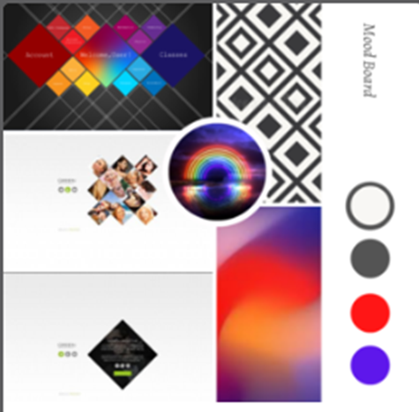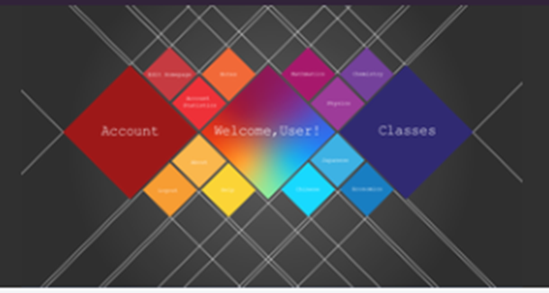

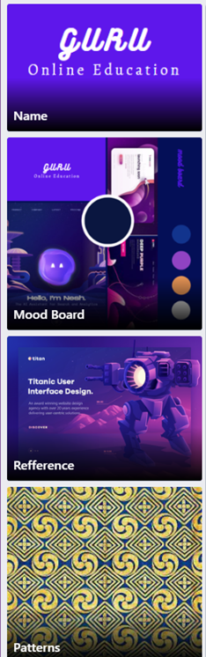

Feedback: Sean Wang

**Concept 1:**

*-          I like the ideas behind it, but I feel the white lines are unnecessary*

*-          The layout of the buttons is a good idea and feels unique, but are we going to be able to make this many pages or use them?*

*-          I think the black and rainbow color scheme with white lines is too broad and therefore isn’t a color scheme as it is every color so it would do us good to refine it into 3-4 colors.*

Specifications:

-          Aesthetics

← (Is concept 2)

*The specifications given for the aesthetic part of it was to have it quite family friendly and to have a simple layout with simple primary colors so as not to distract the users from what they are doing. It should have curved edges with a smooth look to it.*

-          Functional

*Functionally we need to be able to book tutors and I would like to be able to have links to the OLE and different sites to be able to get a better understanding on the topic and also be able to see assessment requirements and past papers.*

Development:

*Concept 2: This was our concept with the colour scheme being put in play and the layout of a normal website being decided with pages for the account class selection and other things like that. This means we have moved away from the video sharing idea and the tutoring side as creating online transactions is really hard and the client didn’t really want that as they were going to be the soul tutor.*

Feedback: Sean Wang

**Concept 2:**

*-           I really like the theme of this website and I feel like it fits the more children like vibe we need for education website*

*-          Would it be alright if you guys were to be able to create a logo and some page layouts so I can see this theme in action?*

Functional Modelling: Aesthetics

Concept 3: *This concept is very heavily tutoring based and acts more like a shop than an education website so not a lot of design was put into this concept before it was pitched*

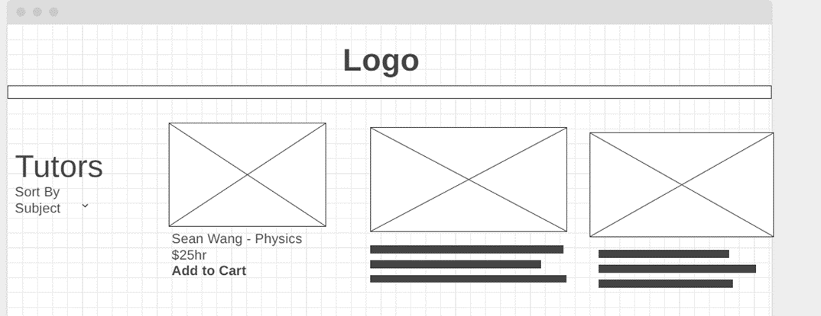

Concept 4: *Following the feedback from last time we added more detail and made it focus more on giving information about the subjects like assessments standards briefs and dates and such and left the design pretty minimalistic in color but with a good layout*

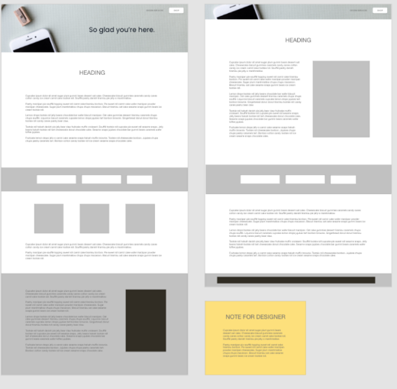

Concept 5: *This concept is more video focused and has a design similar to YouTube. It is still education based however as on the side it has all the subjects and this layout makes it easier to maneuverer and it also makes the content more community based as people can post their own videos instead of watching some created by our tutors.*

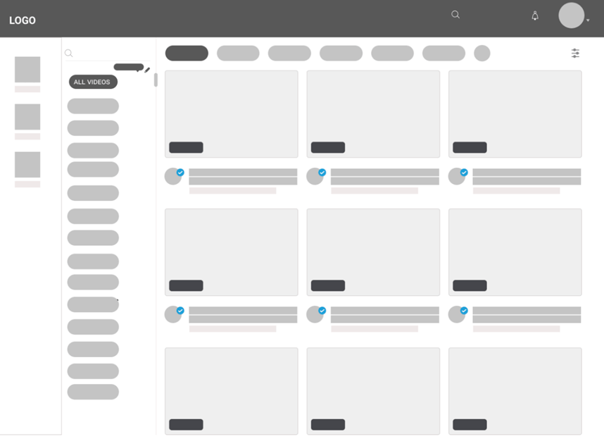

Feedback: Sean Wang

**Concept 3:**

-        *It has a good layout and feels similar to what big websites would have for a shopping site.*

*-          I know this is just a layout but having a colour scheme or just a certain aesthetic would be nice as well*

*-          I think this layout focuses too heavily onto the tutor booking side rather than the education side, I think something like this would be nice, but we should make the educational side the priority*

**Concept 4:**

-       *I Like how this one has a clear aesthetic and good simple layout, but I think its missing some of the elements that tie it too an educational website, for example the layout doesn’t have any button names or page titles*

*-          I think the colour scheme should be more child friend or vibrant as this is more office like and dull*

**Concept 5:**

*-          I feel this is a good idea with the videos and layout like YouTube which would be a good addition to the site but like concept 2 I think we should stick to the basics first.*

*-          I would also like to see a colour scheme from this*

Functional Research:

-          Components special techniques

*The special techniques I want to implement to increase the functionality of my website would be the menu bar which has animations when hovering over and it pops up by itself if you hover over the menu bar icon. After it's out as you drag your cursor across each tab it will have a little animation where an icon pops up and the color will change to indicate that, that is what your cursor is hovering over. My other special technique is that my website could be infinitely scalable meaning the tab can be shrunk and expanded and the website will adapt to it and maintain the right size. Is this very useful in a website because it can be implemented into a phone or just for having smaller tabs.* 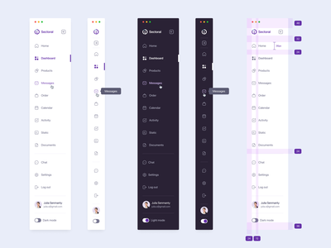

-          Plus / minus / implication for design

*The menu bar doesn't take up too much space as it's just an icon and pops out once you hover over it but the part that is shown I have made sure it fits the same aesthetic and scheme as the rest of the website, so it blends in. The same goes for the scaling technique as it is not shown at all until you scale it and it doesn't really have any implications on the aesthetic but only the layout as it changes slightly once you get to a phone, but all the colours and theme stay the same.*

-          Usability

*The website is very simple with a single nav bar and multiple tabs meaning almost everybody should know how to navigate it as anyone with experience in computers or websites these days would know how to navigate a simple menu bar with a few tabs.*

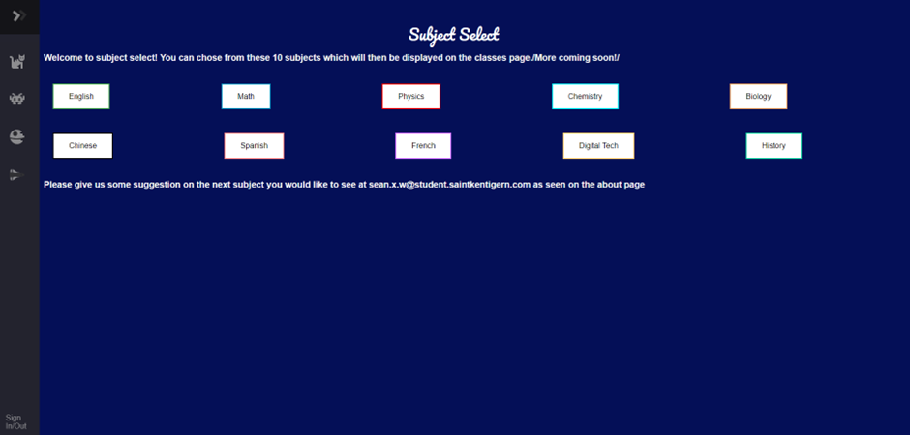

-          End user

*As mentioned before for the target users it's basically the same as the end users and that being Saint Kentigern College students, or any other students wanted to improve their studies.*

-          Device compatibility

*As mentioned before with the scalability it is compatible with iphones and since it is a link it is also shareable across the different types of internet browsers such as chrome, Opera, and safari.*

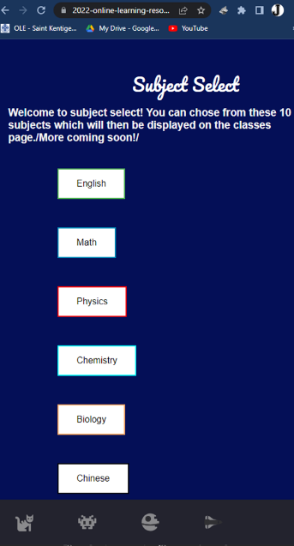

-          Intellectual property/Copyright

*The only thing that I drew inspiration from was the menu bar as I took a tutorial in order to learn how to create it. The menu bar created is still my property though as I am the one who coded it and I also changed up the original design to better fit my website. People who post tutorials online should expect people to copy them and do them therefore copyright wouldn’t be an issue. The only other thing related to other websites would be the idea of it and as it has been done multiple times. It is far from copyrightable though because creating a website on any idea even when it's directly copied from others still is not copyright. The website also has its own things going for it and is slightly different from those on the market today.*

-          Social acceptability

*Websites like mine have already been heavily integrated into today's society and are used by masses of students looking to better their education. This field has already been heavily socially accepted and it doesn't have the drawbacks of some of the other fields as this field is deemed as super positive, so users are encouraged by society to use them.*

Development: research

-          Make changes / modify / refine design using research / modelling

*The changes to the development were basically just compiling all of the previous attempts and combining them. I used the latest color scheme (the purple one) and opted for a pretty simple website layout so that I could add things later. I also added a logo as I thought that would make the website more iconic and easier to remember. I also just filled out the contents of each page to beef it up and make it look like a proper website.*

-          Gain stakeholder feedback

*He said he really liked this and the way it scaled was a big thing for him. He also wanted us to change up the logo a bit so it was more simple and also to add a homepage.*

Fitness for purpose: broadest sense

-          Explain include stakeholder requirements

*The requirements given to us by our stakeholder was to create a website that looked family friendly with OLE links and different tools to use in order to self-teach NCEA subjects. He also wanted a way for the website to have accounts so the users could track their processes which we did by adding a sign up and login function to the website.*

-          What are the criteria

*The criteria was to create an educational website that could also double as a way to book tutors online. We couldn’t do the 2nd part as creating online transactions was a bit out of our skill level, but we did the first part and then some in order to create a good website.*

-          Compare to specifications

*The specifications were to create a website for saint Kentigern students which we did and also unintentionally copied the colour scheme of saint Kentigern in our website which I view as a good thing as it helps with the integration and look of it compared to saint Kentigern college.*

-          Look at the big picture

*In the big picture our website isn’t that helpful realistically as 1 ½ college students wouldn’t be able to produce a educational website which rivals that of the big tech companies which with the research I have done have been proven to put a lot more effort into their website than originally expected. I think we should have scaled back our expectations and tried to come up with a way to effectively create a website without spending a lot of time on certain functions.*

-          Analyse feedback

*Looking at the feedback given it is understood where he is coming from as I have thought the same things and most of his feedback was really helpful in keeping me in the right direction. I think sometimes however the feedback was a bit too optimistic as he asked us to do some really hard stuff which caught us up quite a lot but we persevered through the stuff he was set on and it turned out alright.*

Development:

* Cycle of generation of ideas feedback evaluation

*After feedback was received, I started on the logo as this is pretty crucial. I thought of a monk in meditation as a pretty good logo because it’s linked to the word Guru, and it resembles deep focus. After getting a few images online I decided to use these 2 as a reference whilst I created my own through illustrator and photoshop.*

 *This is what I came up with as the logo. After experimenting with a few different texts this was the base look of the logo I came up with.*

*I chose to use this colour as this was the one used in the final concept, and he seemed to like this the best so this will now become our base layer for the website. I also created a circle around it so it could be easier to create in a circle format for things like the logo you see at the top left of the tab and such.*

Presentation: Final Concept

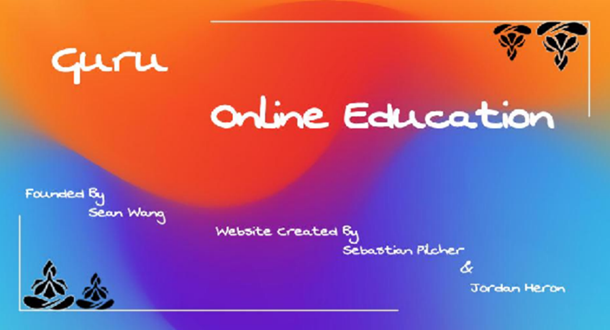*This was the final iteration after 3 tries which he said he was happy with. The color scheme and font of the other pages remains the 2nd iteration as it fits better as this works for a home page but not supporting pages.*

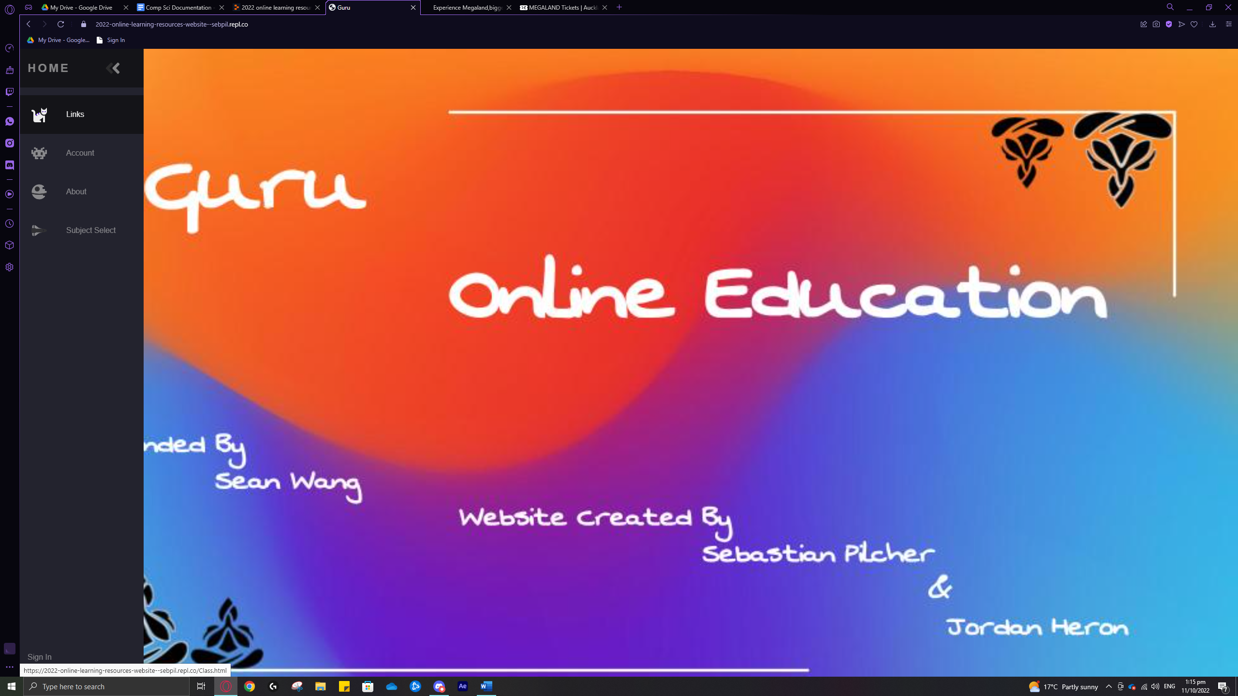

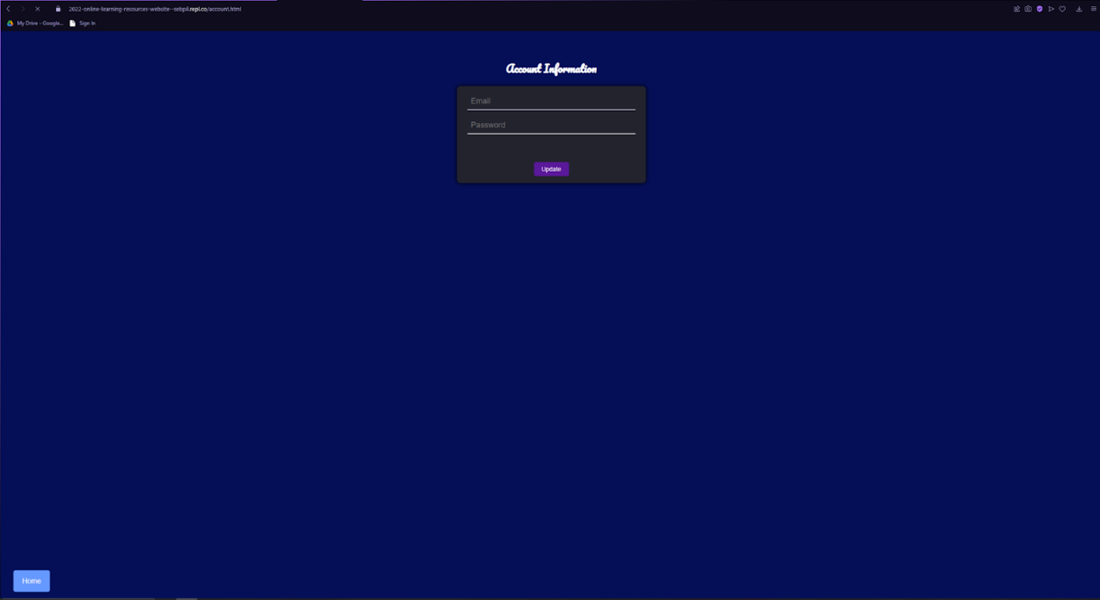

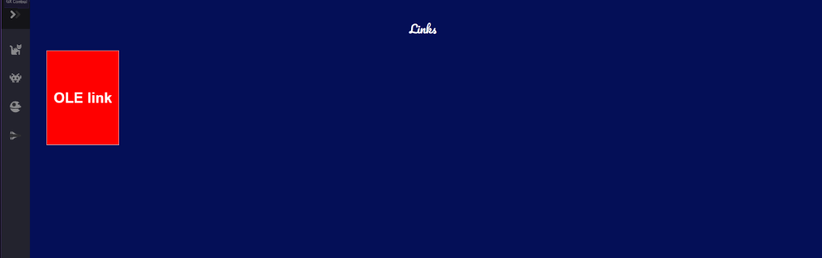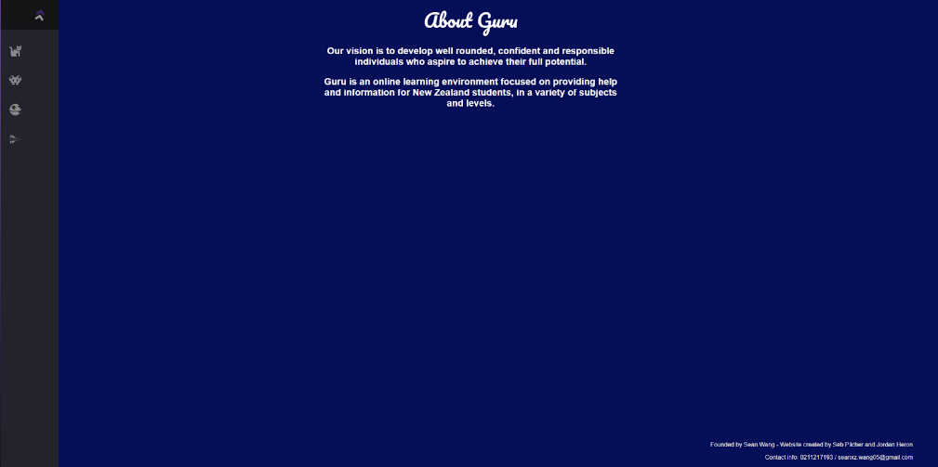

(Phone View)

* Evaluate (comment on process, features. Potential improvements future maintenance upgrades)

The process of designing a website like this was very long and required a lot of work for what I believe is not a product which is 100% as there were so many things to design and code. The features of the website consist of the menu bar with an animated menu, multiple pages, interactive buttons, and a minimizing technique that allows us to use this website on the iPhone and smaller tabs. Potential improvements we could do for the website is to add more content to it, so it is better fit for purpose and add the booking system for the tutors as I gain more knowledge and experience to complete tasks such as these. Implementing the booking system would be very benefitable to the website as it gives it another complex function and it also gets it closer to the goal we started out with.

Website Link:

<https://2022-online-learning-resources-website--sebpil.repl.co>



2.4 Prototyping

Jordan Heron

21.10.2022

*Replacement for 2.4 Media*

Task:

Advance Techniques:

Software Tools:

My Code: Decomposition

Testing: trailing

Summary:

Links:

Sustainability In Design

Jordan Heron

21.10.2022

*Replacement DCAT*

Sustainability: Importance

* What is sustainability
* Why is it important?

Sustainable: Prototyping

* What is sustainable prototyping?
* How can you relate it to a brief you worked on this year?

Design:

* What is sustainability (in depth)
* What is design
* Describe the 3 factors of sustainability

Brief: Research

* Describe brief
* Connect to main ideas
* Research (important)

Software Life Cycle: Analysis

* **Stages - connect to project**
* Define innovation
* Completing priorities of compromises
* Design process
* Factors impacting the sustainability of the digital products

Evaluation:

Animation and Motion   
Documentation

___

Jordan Heron

Title Page: Introduction

2.8 Digital Outcome

Jordan Heron

30.9.2022

*Bible Animation*

Conceptual Design: 91897

Research: OneNote

Before I started creating a plan of what I was going to do I had to decide how I want to do it, so I researched styles of animation such as 2D, 3D, traditional and stop motion and art styles and how each conveys a different mood and each with its own upsides and downsides.

I then researched bible stories and read through them to find which one of them was the most interesting and the best fit to animate into a story.

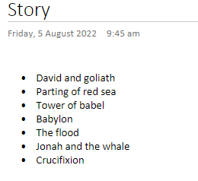

With this I then created the script which had to be cut down multiple times to be able to fit in the 20 second time frame:

(Script 1)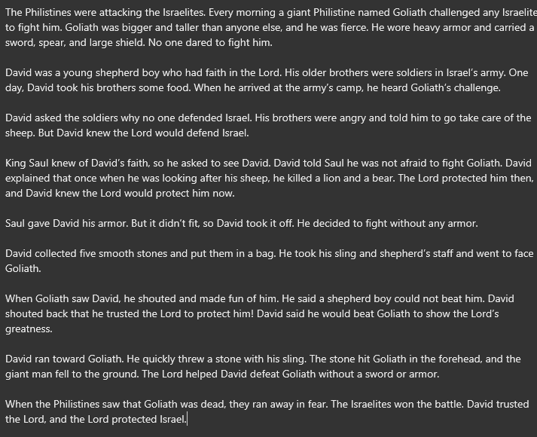

(Revised script)

David collected five smooth stones and put them in a bag.

He took his sling and shepherd’s staff and went to face goliath.

When goliath saw David, he shouted and made fun of him: he said a shepherd boy could not beat him.

David ran towards goliath.

He quickly threw a stone with his sling.

The stone hit goliath in the forehead, and the giant man fell to the ground.

I then researched different styles of animation within mediums to discover what I wanted to do, and I looked at the benefits and downfalls of each and how realistic they were for me to achieve. Also, which still better suited the theme of animation.

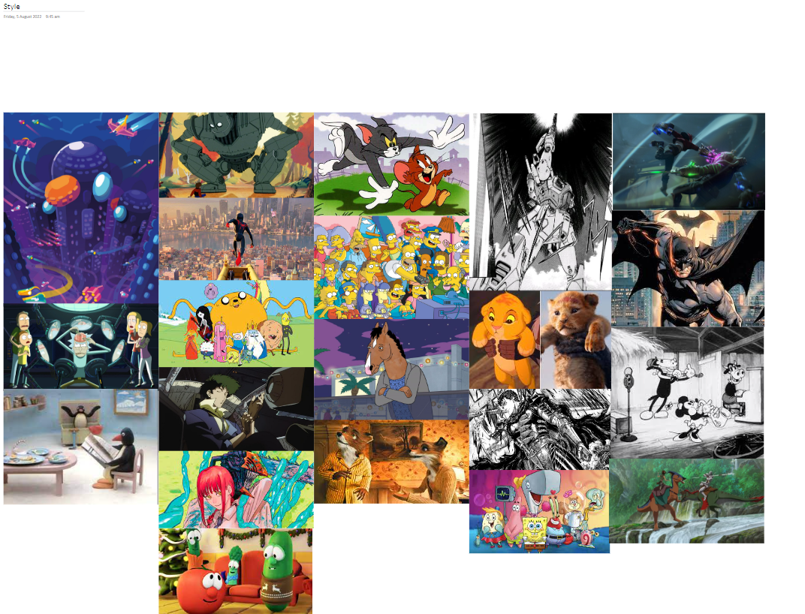

After researching the story and style I researched the characters in my story and what they looked like and how they were represented in the media today and before. I looked at sculptures by Michelangelo and different carton representations of the character and story.

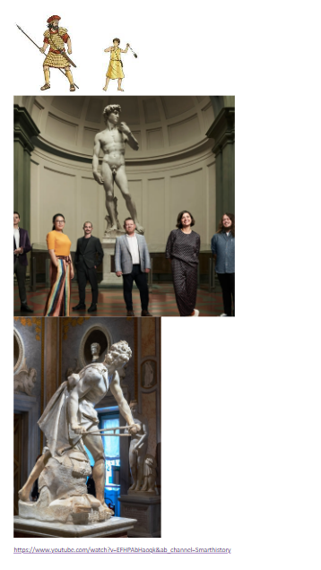

Animatic: Animate 2D

I decided to do my animatic in animate with the 2D style as this is what I found as the easiest to do quickly. I was a bit of a struggle getting the audio to work but it did in the end, and I was able to plan out each scene and get it linked to the audio.

Decomposition:

Research:

* Art style
* Style of animation
* Bible stories
* Characters from bible story displayed in media (After choosing a bible story)

Planning:

* Create a Gannt chart with decomposed list
* Revise Gannt chart after 2-3 weeks to keep it on track
* Repeat and give feedback on how things went according to plan

Animatic:

* Create the narration
* Input it into animate
* Animate
* Feedback

Character Design:

* **Test different software’s and models**
* Find the most accurate model
* Change the model to fit the story better
* texture the character to fit the setting
* rig the characters

Object + Background Creation:

* **test how to use 2D paint within blender**
* **test how to download useful background assets such as bushes and trees**
* use information gathered by animatic to create sections of needed background in 2D
* model the sling shot
* model the staff

Sound:

* **Test different microphones**
* **Test using AI generated speech**
* Implement one of these strategies
* Change it to the right audio file so its compatible with Adobe

Animation:

* Arrange the background for each shot
* Arrange the characters for each shot
* Break up each shot into its own project
* Animate the character
* Texture scene where feels fit
* Render

Documentation:

* Get the rubric
* Get the right format
* Layout the document in sections
* Complete each section

I broke down the animation into several main categories after looking at the marking schedule and using my experience from last animation of how a animation actually works. The main categories are the animatic, character design, asset creation, sound, animating, documentation, planning and research. I then broke it down further into each part of each section so that I know what to do and I don’t leave anything out. It also helps me create a list of priorities in order to understand what really needs to get done and what isn’t too important.

Gannt Chart: Trello

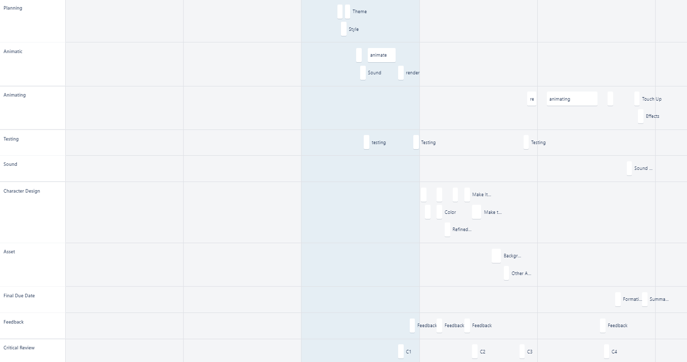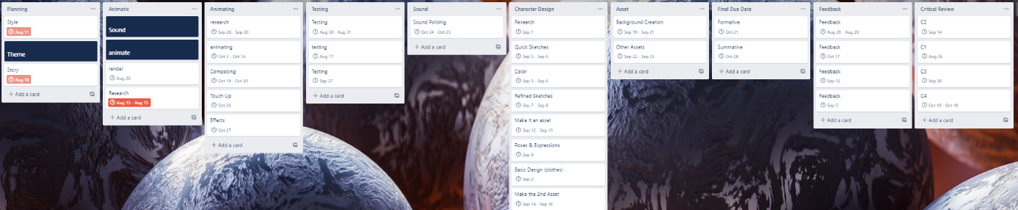

After decomposition I’ve put all the different tasks in the timeline and using my experience from last time it was a lot easier to get the things I need in there and filter out the unnecessary things. It also was a lot easier to be able to plan out the times and get them more accurate which meant I had to review it less. Using this planning message, I was able to gain a better understanding of my project and was able to get to work straight away without getting overwhelmed by the size of the project.

Critical Review:

* Critical review 1

The first critical review was after I had created the Trello website and finished my animatic and gotten feedback. I felt pretty confident at this stage as I was well on track and slowly understanding more and more about the things in blender, I need to do in order to achieve this animation, so I didn’t make any changes to the plan and was happy with the way things were going.

* Critical review 2

The 2nd critical review was after I had been testing blender for a week and trying to animate it. It was at this point I decided to move on from blender as it proved to be far too difficult and tedious as I was slowly running out of time, so I had to switch to hand drawn traditional animation as it was the best time efficient method for me at the moment. This also meant I had just lost a week on blender, +so I had to reduce my current plan by a week and also implement it to traditional animation instead of blender.

Animation Style: 3D

|  |  |  |
| --- | --- | --- |
| Name: | Strengths: | Negatives: |
| 3D Animation (Blender) | Very good textures and could be easy creating characters as they are downloadable so I can edit them to fit my animation. After modelling the character all that is needed is to animation. Also looks the most life like. It has really good effects. There are also a lot of shortcuts that make the process a lot easier. | Not very easy to be creative with it and make something that isn’t lifelike and It takes a lot of work to create a character and background. It is also quite a hard software to learn and to run. Backgrounds need to be developed a lot more and you have to do things like lighting. |
| 2D Animation (Animate) | Animate is very easy to use and very simple. There are a few tools to use which is beneficial such as tweening and symbols. You can switch between hand drawn and computer generated and is probably the easiest one to do as the production is very fast. It is also good for increasing the frame rate and other values. | It doesn’t have a lot of things you can do with it, like tools such as blender, and the product is heavily dependent on the user’s artistic ability. |
| Traditional Animation (Animate) | This is very simple as is quite easy to do fast as the animation is basically one just chunk of the same work so it can be easier to do, and less thinking is involved. It is also better than 2D animation for making things fluid. It also has the most creative freedom. | It is very repetitive, and the frame rate effects the work load a lot meaning there is a sacrifice between quality of the art versus more frames. Also, there is nothing you can do to help yourself, no tools to be able to speed up the process. |
| Stop-Motion Animation (dragon frame) | It has a very unique style and has a lot of different applications and requires a lot more of a hands-on approach. | It is quite limited material wise and is very time consuming. A camera is always required and a computer. It is also limited in effects as editing or adding a layer of computer wizardry on top changes the authentic look. |

* Final decision

I will animate with blender and do 3D animation. I think this is the best medium for me to challenge myself and learn and grow. There is a lot of potential with blender and learning special techniques could help me cut down on time a lot. 3D also allows me to be different from the rest of the class. I also feel closest to this medium as I feel it is the best suited to my skills.

File Structure:

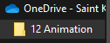

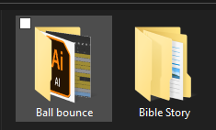

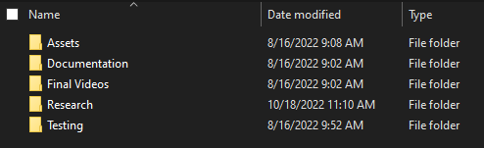

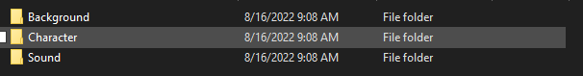(assets)

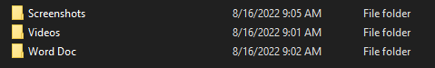

(Documentation)

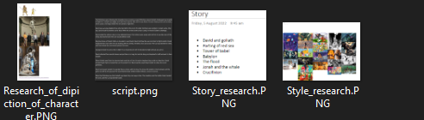

(research)

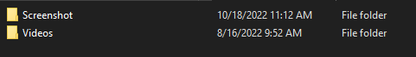

(Testing)

The main file is called 12 Animation and is uploaded onto OneDrive so I can access it across both computers. This allows my files to be protected if something were to happen to one of my computers and it keeps them safe, and future proofs them. After that it goes into each project, then it moves to the main page where it gets broken down into its main components which are assets, documentation, final videos, research, and testing. I draw inspiration from the decomposition list but have modified for the files. For most files I have broken them down again into screen shots and videos but for things like assets I broke It down into characters, sounds and backgrounds. I also made all my images png’s and all my videos into mp4’s because it makes things easier and more accessible, and it can be put into things like premier pro and all the images and videos will work. I used a png converter on the web and VLC media player to convert the videos.

Relevant Implications:

* Accessibility

The way the target audience can view the animation is through Microsoft stream which is a platform that is linked to the whole school meaning any students or teachers can gain access to it on their laptops. I believe the intended users are able to understand the content as it is just a narration with an animation on top of it and it’s very simple, it also teaches a bible story which could be what they are learning in class so it could educate them more.

* End users

As the brief stated the end users are going to be the ones viewing the final animation, these people will be the middle college Christian Education classes. This means their age is around 14-15 which means most things should be ok but showing too much gore or things like that need to be toned down especially since it’s in a classroom. It being a Christian education classroom also means it must be quite accurate as it is a learning experience for them. The end users can also be expanded to the entire saint Kentigern college as I will be uploading it to stream which is viewable by the entire school which is around 2,000 people. As the main end users however I need to make sure this animation has a high retention rate especially since the younger has a very low attention span. No subtitles are needed as everyone in the college can understand English enough to be able to listen to the narration.

* Legal

The legal applications to the animations are all covered meaning that there isn’t anyway this legal contradicts something else. Intellectual property isn’t applied as I drew inspiration from the bible which can’t be claimed as copyright. Creative commons is the models I downloaded into my blender as the characters which could be like other if they use it to but the website has free downloads so it can’t be claimed either. The ethics related to the bible is to just be informational and to not change the messages conveyed into the text. There isn’t any text or images implemented into the animation so there is no trouble there.

* Future Proofing

I have backed up all my files on the cloud so if something were to happen to this document or the animation, I still would be able to access it and it wouldn’t be lost, same goes for all the assets, screenshots, and videos. I made my animation in blender for many reasons but a big upside to it is it can be rendered again and again with better and better quality so that in the future when the current resolution is considered low it can still be rendered at a higher resolution without any changing or work on the animation. All my video files are mp4 and all my images are png’s meaning they are very access able.

* Aesthetic

The aesthetic I was going for was a roman empire kind of look as in most media representations of the story that’s how they are conveyed and its also the setting. That means the colours and materials used in the background and character match this aesthetic, with their Armor, clothes, weapons, and surroundings. The aesthetics that appeal to my end users and a stake holder are the same in which their expectations would for it to be as accurate as possible meaning that the clothes and environment fit that of the time period the piece was set in.

Testing:

* AI generated speech

Testing this was very annoying as most of the websites I found required an account first then after an account creation you could create the audio wanted but you couldn’t download it. After I found that I used the revised script I added it to the text and played around the voice to get the most realistic sound I could find given it wasn’t the premium version. After this I slightly increased the speed of the narration, it fit into the 20 second format. This is where I decided to user AI generated speech over a voice over by me as this was far more consistent and more impersonal meaning I was more detached from the project which I fell gives it a more professional look.

* Microphones



I used the software audition to be able to edit the audio better and gain a better understanding of this medium. I tried multiple microphones with this program consisting of my computer’s microphones, my headset at home and a friend’s air pods. I tried each one and liked the air pod audio the best. The image below is my testing experience on testing the microphone at school.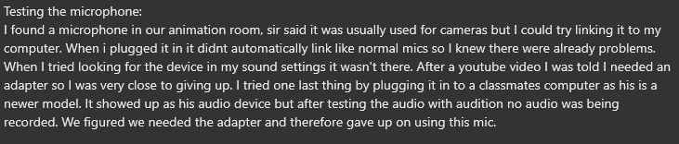

This is where I decided if I was going to use a mic and have a voice over I would do it in adobe audition, this is because of my testing I was able to determine that the best choice for the quality of sound was the air pods and that the software Au or audition is pre-installed on the school computers and I seem to be able to manage that software pretty well.

* Testing planning websites

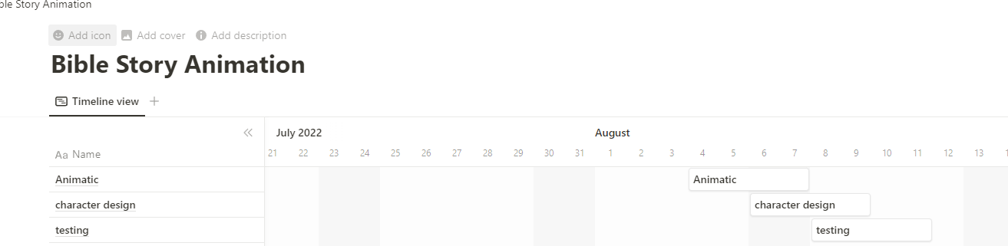

I first started with notion as it is what I did last time, and it was pretty easy but because I used it before I was aware of its limitations, so I looked for another site with this to fall back on.



I then realized that Trello a website which I’ve used before but never for Gannt charts has a Gannt chart function and I was more proficient in Trello and found the layout more pleasing and functional, so I opted to use this website instead.

I did however discover that using the Gannt chart function on Trello was part of a 30-day trial for Trello premium which means halfway through I wasn’t able to look at in the Gannt chart mode, which was the whole point, but I kept using it as the normal version is good enough. Up until I got to my critical review which I then had to just revert back to notion for anyway.

* Testing blender

3D animation was the style I chose because of many different reasons but this means I had to use the software blender. I was familiar with this software as I have done other animation project with it before. My plan was to use 2D drawings as the background that I created through tutorials and model the weapons myself. I was going to get my clothes from SketchFab and create my models through Mb lab which is a add-on that allows you to create characters through settings. I had to get a older version of blender installed as well because the add-on doesn’t work with a newer version. This took me quite a while in the end, but I managed to do it from getting the install of a USB that someone had. After this was done, I had to install and add Mb lab as an add on which was pretty easy. I began messing around with the character models which made me start to realize how complicated this was, but after a while my first iteration was completed.

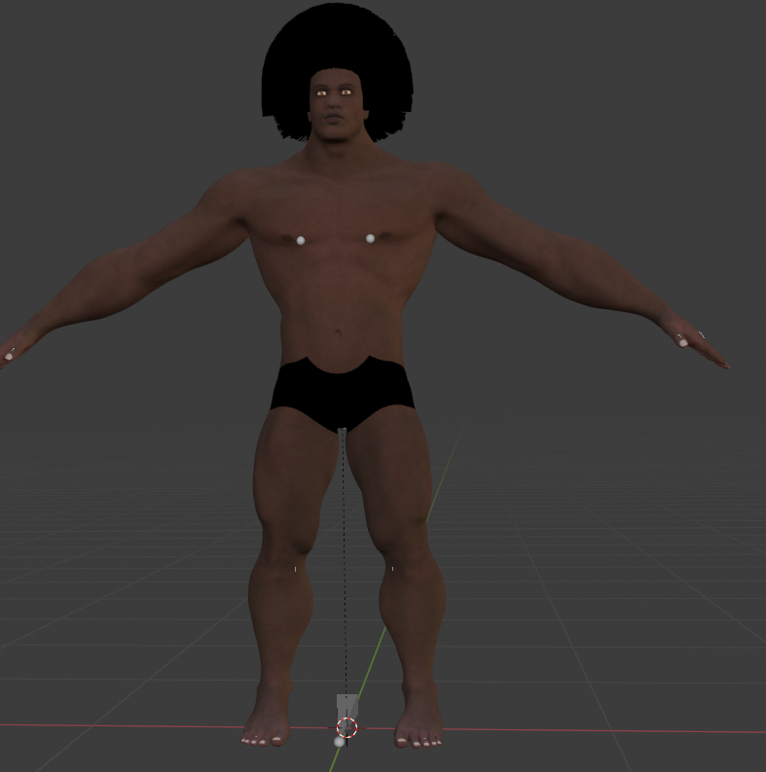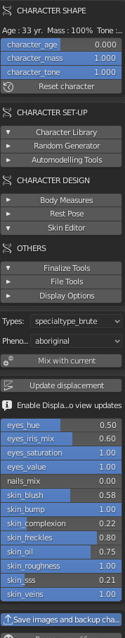

After this I realized I had to create a new one as forgot to add the inverse kinematics and the basic muscles so I couldn’t animation it, so I redid with the same settings but now with these features. After a rough model was created, I tried to add clothes. This took me a while to even figure out where to start as all the tutorials I found proved to be not useful. After a while I figured out that I need to import the clothing as a Wavefront or (.obj) file. I looked through sketch fab for some roman Armor and found something I liked so I downloaded it and tried to import it but got this error. 

I tried to download it as a .obj but I couldn’t so I tried to find another way to get my clothing into the animation. That’s were I found an add-on for SketchFab that allows you to upload any SketchFab model to your blender project, so I installed that. After logging in I search for the asset, I found before and tried to Import it but it crashed my computer, so I restarted it and redid the model and it worked the next time.

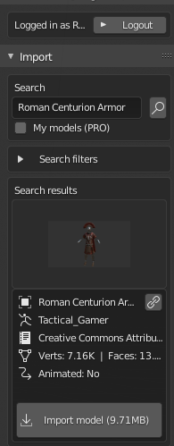

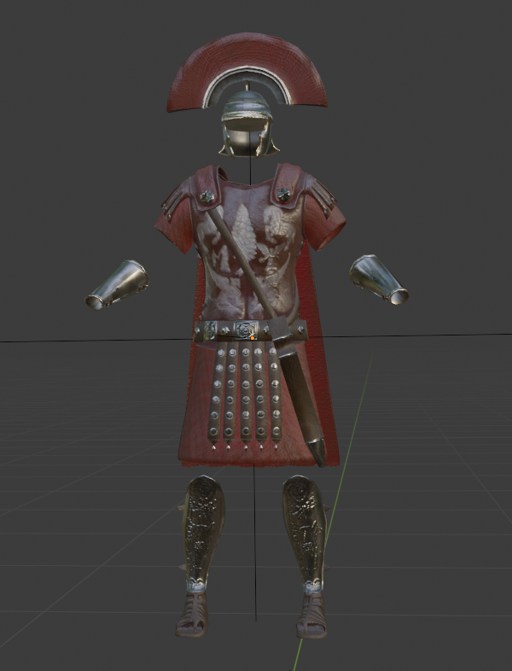

After getting the model imported, I tried to fit it too my character but quickly realized that it was going to be impossible if I couldn’t link it to the model as it would just move away after I start animating it and it will also take for ever to shape it to his body. After that I tried to use proxy fitting.

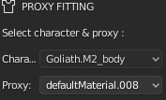

But it wouldn’t allow me to add a new proxy so I could use these clothes. I then tried to remove most of the Armor and just got with the skirt and belt thing and modelled it to the character but again when I tried animating it, it didn’t stick to the character.

At this point I realized I had to figure this out and do it when another character as well. Then figure out how to paint in 2D in blender to create the backgrounds and then animate these characters which turned out to be super complicated, and difficult to animate.

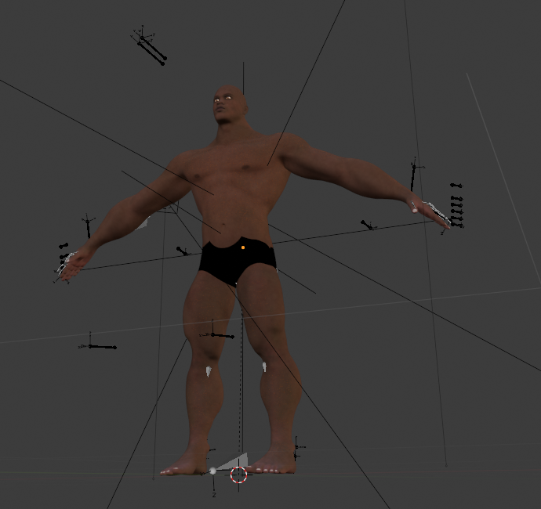

* Testing animate

Because I did my animatic in animate, I already had the audio ready to be used in animate and I new how to create the backgrounds, my plans changed after blender to traditional meaning the only way to finish in time was to rotoscope. I used myself as the origin and tried to upload the video to animate which proved to be quite hard as I thought you needed a FVL file for it to show up in the timeline as frames, however this is only if you want to export the video as well which I didn’t as it’s a reference. 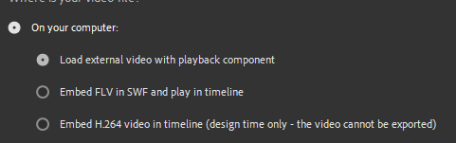

After this I had trouble because the video was much longer than it was before and that is because it was made to fit into the frame rate and it had a frame rate of 24 so it doubled in length. I just had to go back and watch a tutorial on frame rates in Ae to change it and re-input it.

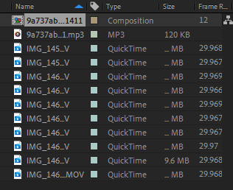

After this I was set to animate which didn’t come with any problems. However, after I exported it there was no sound so I put it back into Ae and added it then re-exported it

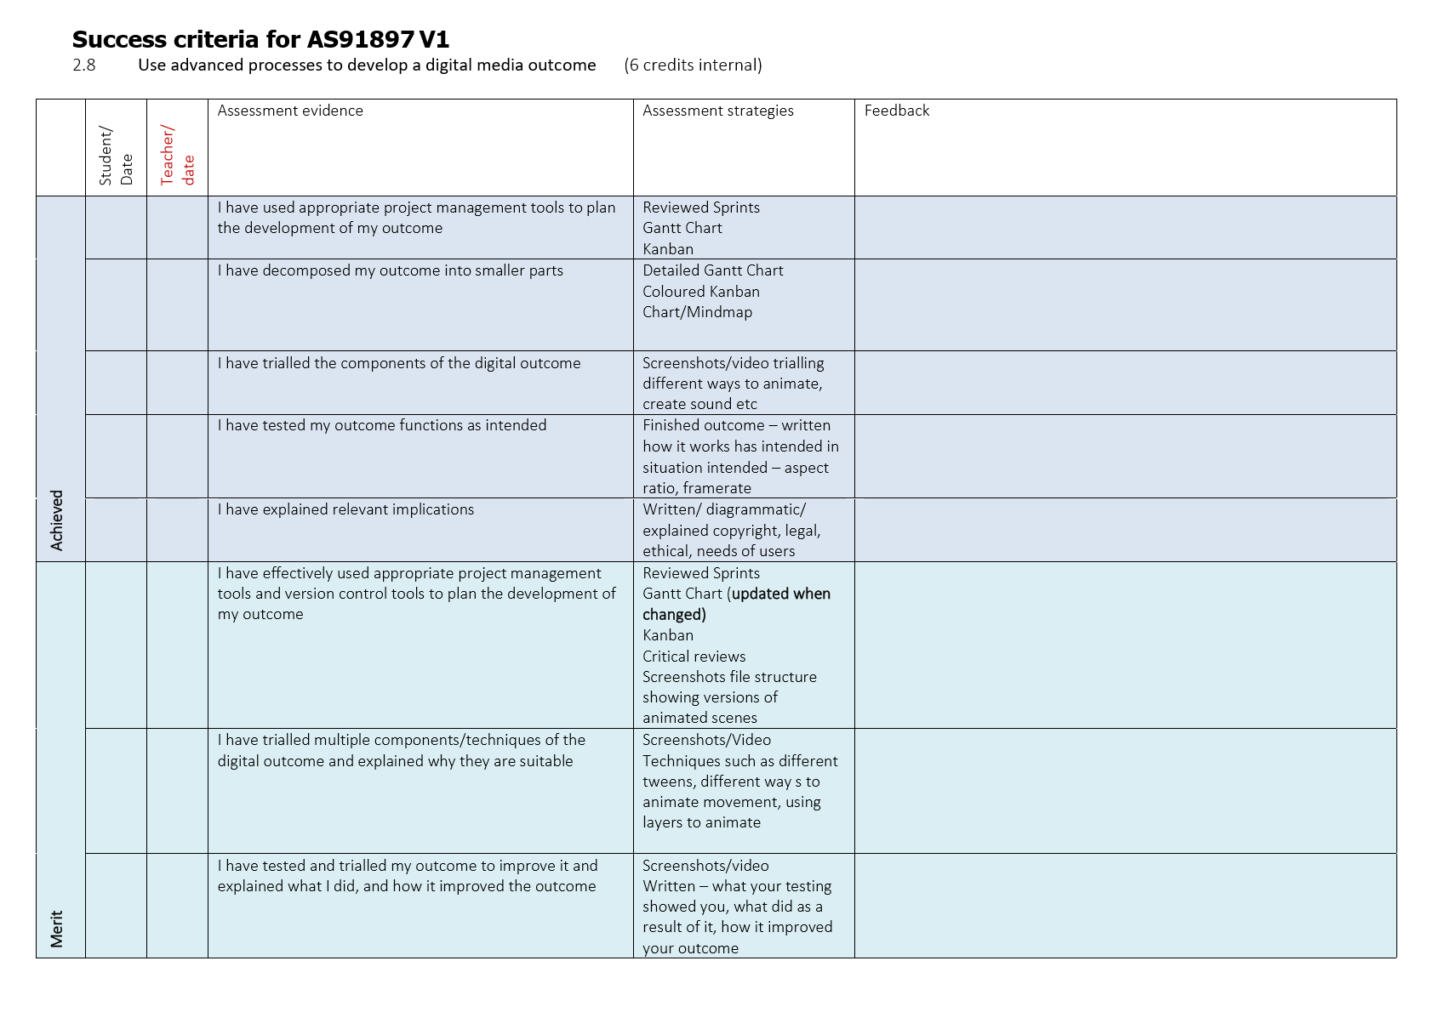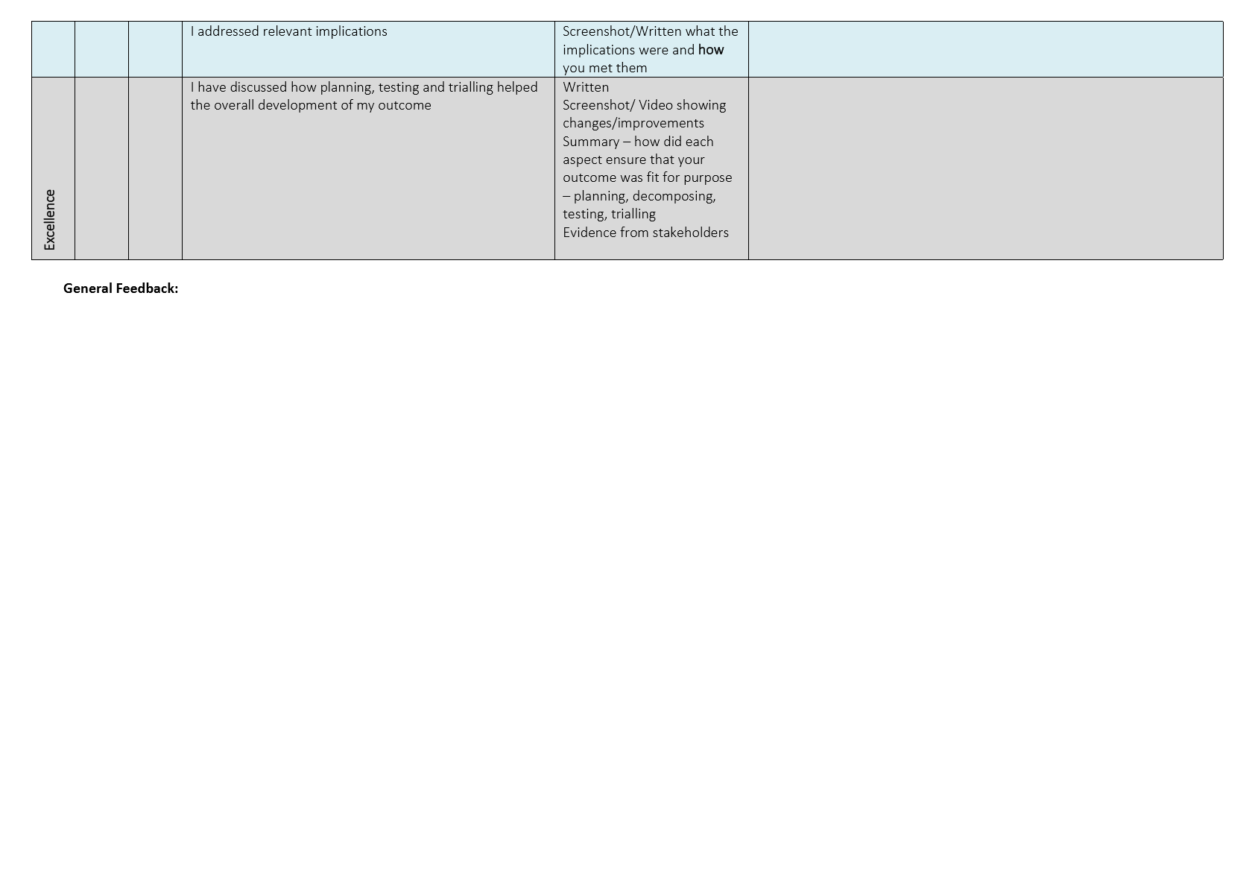

**2.2 Select and use planning tools to manage the development of an outcome AS91355**

**Introduction**

What is project management and why do we use it?

* + Project management is the breaking down or decomposition of tasks spread out on a timeline to control each aspect of the project and make it easier to stay on track and know what to do and when.

Where have you seen it used – your experience and where it is used in industry

* + I have seen project management in almost every industry especially those relating to computers or development/construction.

How is it vital to the successful development of an outcome?

* + It puts everything on track and makes it easier to start as it has been broken down into smaller pieces it also helps not forget about small details that could have been missed without planning.

**My Brief**

**Select and use planning tools to manage the development of an outcome involves:**

* selecting planning tools informed by a review of existing planning tools
* using selected planning tools to set achievable goals, establishing resources required and determining critical review points
* managing the development and reviewing progress as planned to ensure completion of an outcome.

**Select and use planning tools to effectively manage the development of an outcome involves:**

* selecting planning tools informed by an analysis of existing planning tools
* reviewing progress at critical review points to revise and/or confirm goals, resources, and planning tools to ensure completion of an outcome.

**Select and use planning tools to efficiently manage the development of an outcome involves:**

* ongoing reflection on goals, resources, and planning tools to optimize time and material use to ensure completion of an outcome.

**Tools I am looking at using for Planning my outcome**

|  |  |  |  |  |  |  |
| --- | --- | --- | --- | --- | --- | --- |
| Tool/Method | How is the tool used in industry and at what part of the process would you use it?  **(When is it used?)** | How have I used it in the past | +ve of the tool/method  **(Talk about what it does/features)** | -ve of the tool/method  **(Talk about what it does/features)** | Justification for use/not use | How the tool is used to mitigate risk (and what risk) |
| Notion/Gantt chart | It is used as a way to plan out and plan a project | I have not | It is pretty good for having exact dates and is well laid out when doing a Gantt chart | It isn’t the greatest for determining what is being done though | I’m going to use it as it is very good for decomposition. It is also and very simple and easy to use. It has a very good layout out to be able to see what is going on in your timeline and your able to make comments on it. You can also see the day it is now compared to when you have to do other things to help you get things done. | It is good for planning out the dates |
| Kanban | It is used as a way to decompose a project | I have not | It is very good for displaying what is done and getting done | It isn’t very good for a time period though as there are no dates on it | I’m going to use It as in combination with the Gannt chart it works really well. I’m using Kanban to see how much of the project I’ve done and need to do, it is a great way to track progress. I’m creating a physical Kanban with post it notes on the wall instead of online as it is better reminder as I see it more and its just easier for me to able to change them around. | It is mitigating risk by laying out what needs doing so things are forgotten |
| Trello | Trello is a pretty similar to their Kanban but isn’t restricted to just 3 categories so you can have lots of things there like when certain things are needed | I have used it for digital technology | Its good for decomposing a project and getting everything ready not just tasks but other things like the brief, when things are due and when certain things need to be used | It doesn’t have a timeframe function like the Gantt chart | I’m not going to use it as I’ve already chosen to use the other two, so I don’t really need to use this one as it’s a slightly worse combination of the other two. Trello has both a way to use a Kanban and also a Gannt chart which is super beneficial as its in the same place and there are some things you can do in the Gannt chart in Trello you can’t in notion like grouping. Grouping is not really needed for this project however and I found Trello way more complicated and harder to use. You can also only use its better functions with premium or a 30 day trial which would run out before my project ends. | It is mitigating risk by laying out everything you need to do so nothing is forgotten |

**Tools I will use**

|  |  |  |
| --- | --- | --- |
| Tool, I chose to use | Justification of why I chose to use tool | |
| Kanban | I chose to use Kanban over Trello as a way of managing my project as I liked the simplicity of it and how it was a physical reminder in the classroom of where I was at. I also found it made a good pair when used with notion/Gannt charts to get the best project management. It helped me mitigate risk by being a physical reminder of what I was doing and what needed to be done. | |
| Notion/Gannt Chart | I chose to use the Gannt chart over Trello as it had timelines and a better form of viewing which allowed me to understand my deadlines better and decompose and lay it out better. I also found it made a good pair when used with Kanban to get the best project management. It helped me mitigate risk by laying everything out and making sure I don’t forget anything. |

**Resources**

|  |  |  |  |  |
| --- | --- | --- | --- | --- |
| Equipment | Knowledge | Social | | Other |
| Laptop | I know a lot about this because I’ve had it since year 9 and navigation won’t be a problem | Everyone has got there own so there is no limited supply | |  |
| Camera | I have used cameras in the past but not hooked up to computers or for stop motion | There is really only one good set of things we need for stop motion so this will be in high demand |  |
| Drawing pad | I have not really used these before, but they look pretty simple and easy to use | There are quite a lot of these in class and not everyone will be using them at the same time so the supply will be fine |  |
| Lights | I haven’t really used these types of lights before, but they are simple and will be easy to figure out | Lights are only needed for stop motion and there are 2 sets, so I think there won’t be an issue there |  |

I haven’t really use Kanban for managing tools, but I did use my notion/Gannt chart. For the Gannt chart I just had specific times periods when I was working on something that needed a physical tool that I didn’t have to be ‘booked’ in a period inside of the time I was doing that specific thing. For example, I booked out a camera a light for 2 days during my stop motion segment after I had created my assets. This let me talk to my classmates about the specific days they would need to use the tools so that there is no overlap and people can get the tools they want.

**Critical Review**

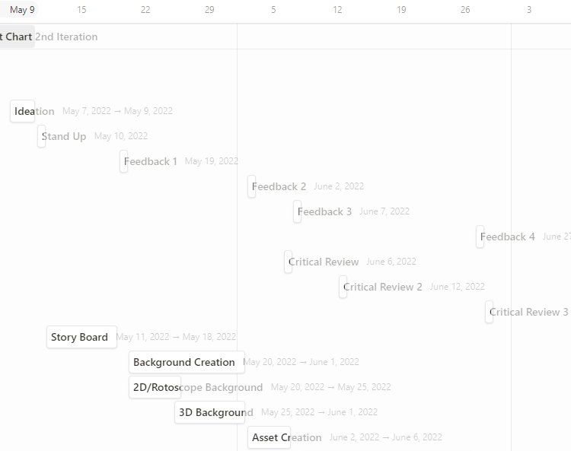

1st Critical review:

* + I had been away from school for a while due to covid and didn’t get as much work done as I would have liked so I had to shorten everything a bit to get it to fit. I also realised that the backgrounds weren’t as hard as I anticipated so I wouldn’t have to allocate as much time on them as I thought.

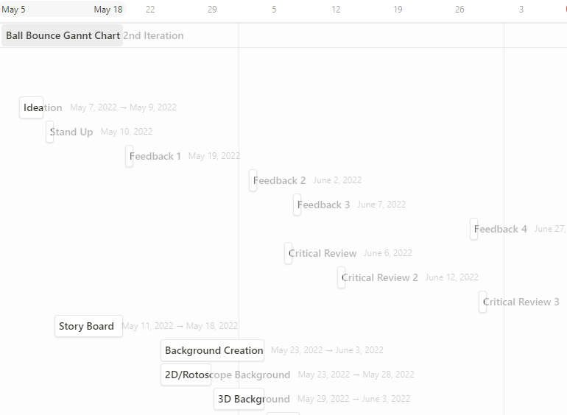

2nd Critical review:

* + This review is just after the 1st one, when I have done my asset creation and backgrounds. I had managed to complete my backgrounds and asset creation on time before the 2nd critical review and got back on schedule. I did another one right after my first one as things were a little crazy I wanted to double check I was on the right track. This is also right after a feedback point which means I may have had to change some of my assets if the feedback was negative which fortunately was not.

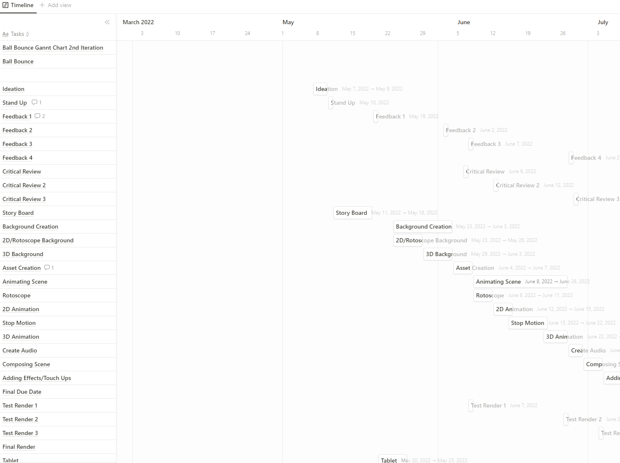

3rd Critical review:

* + This review was scheduled to happen after the completion of all my animations, but they took a little longer than expected and I am still finishing the last one so I’m not too far off track, but I had to slightly reduce the time I gave for composing the scene as I also realised that it is very easy to do so, and I needed more time for the other things like audio. This is also the last critical review.

**Summary**

My outcome benefitted from the use of planning tools because everything was a lot easier to keep track of my tasks and it work out well knowing everything I had to do and when it should be done so that I can dedicate my full attention to the task. I know the tools I have used being the Kanban and Gannt chart suited my project as it was an animation project with several parts which all can be managed by these tools. I mitigated risk by staying on schedule with my project and planning out everything, so I don’t forget anything, these tools allowed me to account for everything in my project and forced me to keep it on schedule. I would try dedicating more time to the parts of the project that are seen like the backgrounds and animation as I feel the art wasn’t as good as it could’ve been, and I spent too long planning and stitching together the project.

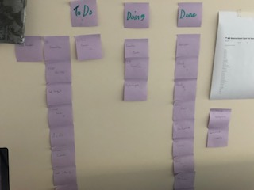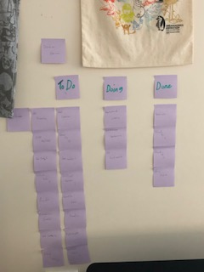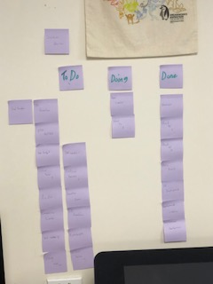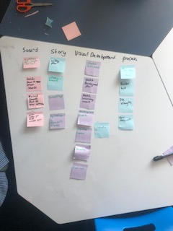

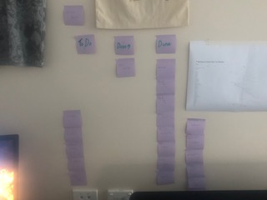

Img 1 = 1st week decomposition Kanban

(No 2nd week Kanban as the real Kanban was start in week 3)

Img 2 = 3rd week Kanban, fully decomposed and with a little completed

Img 3 = 4th week Kanban, more completed

(5th week wasn’t taken due to me having covid and no progress was made anyways)

Img 4 = 6th week Kanban, most completed/doing

(7th week Kanban wasn’t taken as I was away sick)

Img 5 = 8th week Kanban, almost everything completed

(9th week Kanban wasn’t taken as this is the week, we handed it in, so everything was done and I was away on the final Friday)

(1st Iteration Ganntchart)

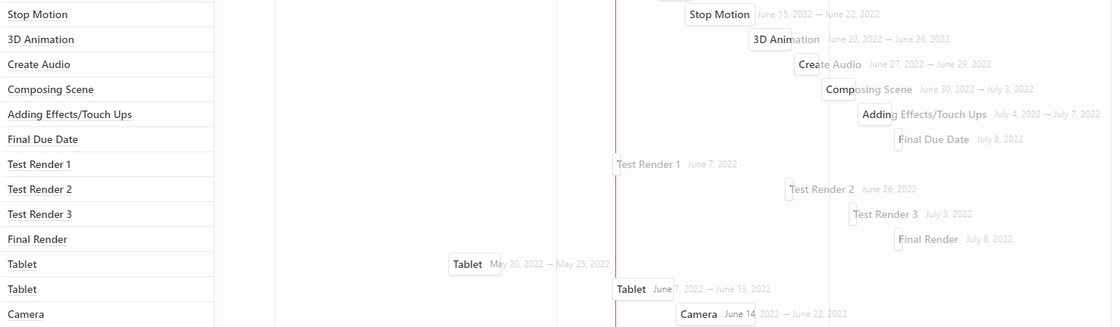

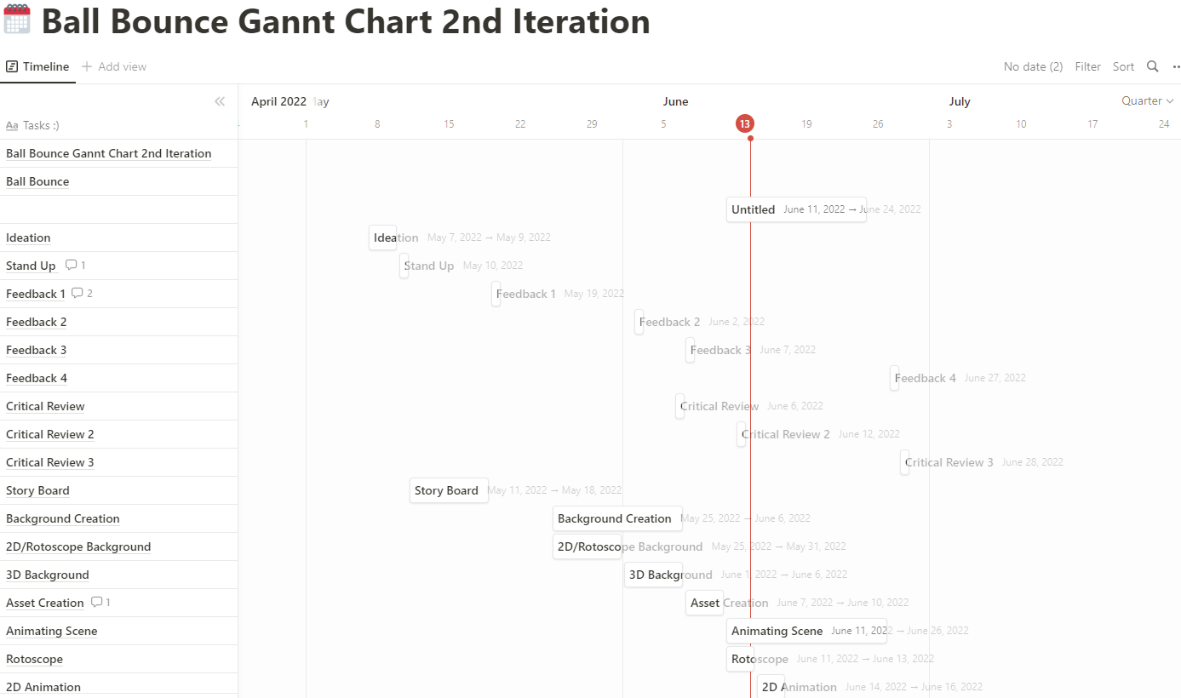

(2nd iteration Gannt Chart)

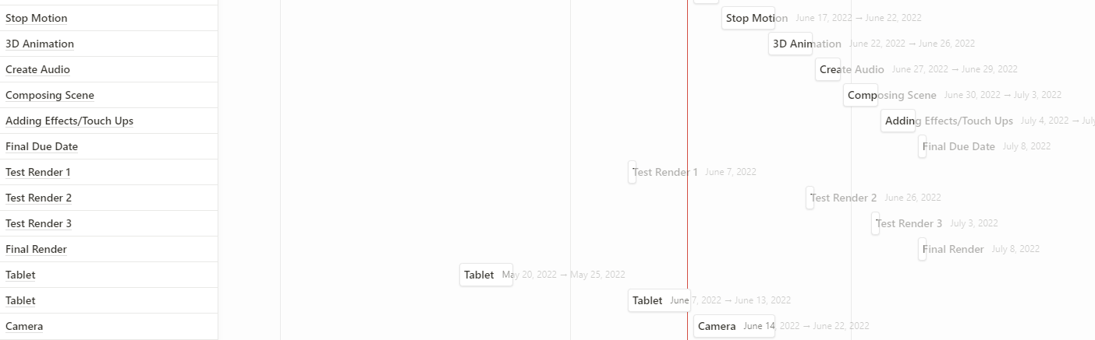

(3rd Iteration Gannt Chart)

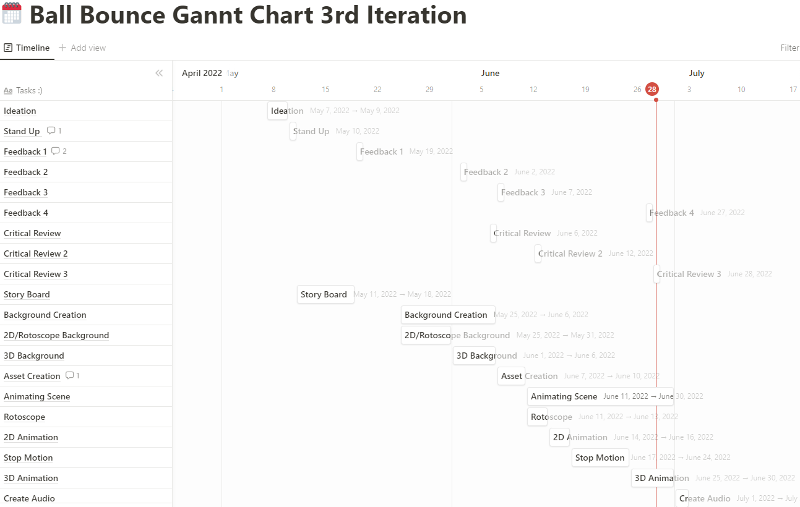

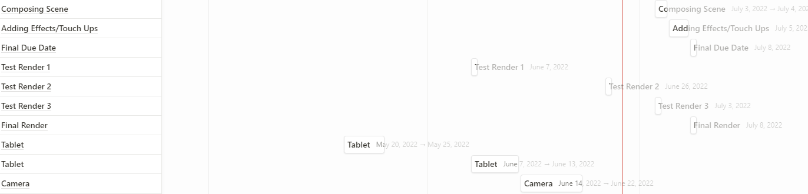

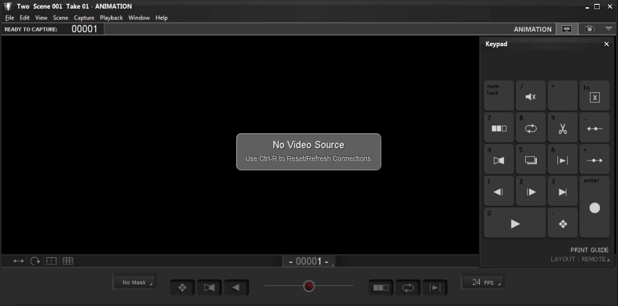 (Onion Skinning In Dragon Frame, no real photo was taken for stop motion as I wasn’t using this computer and forgot)

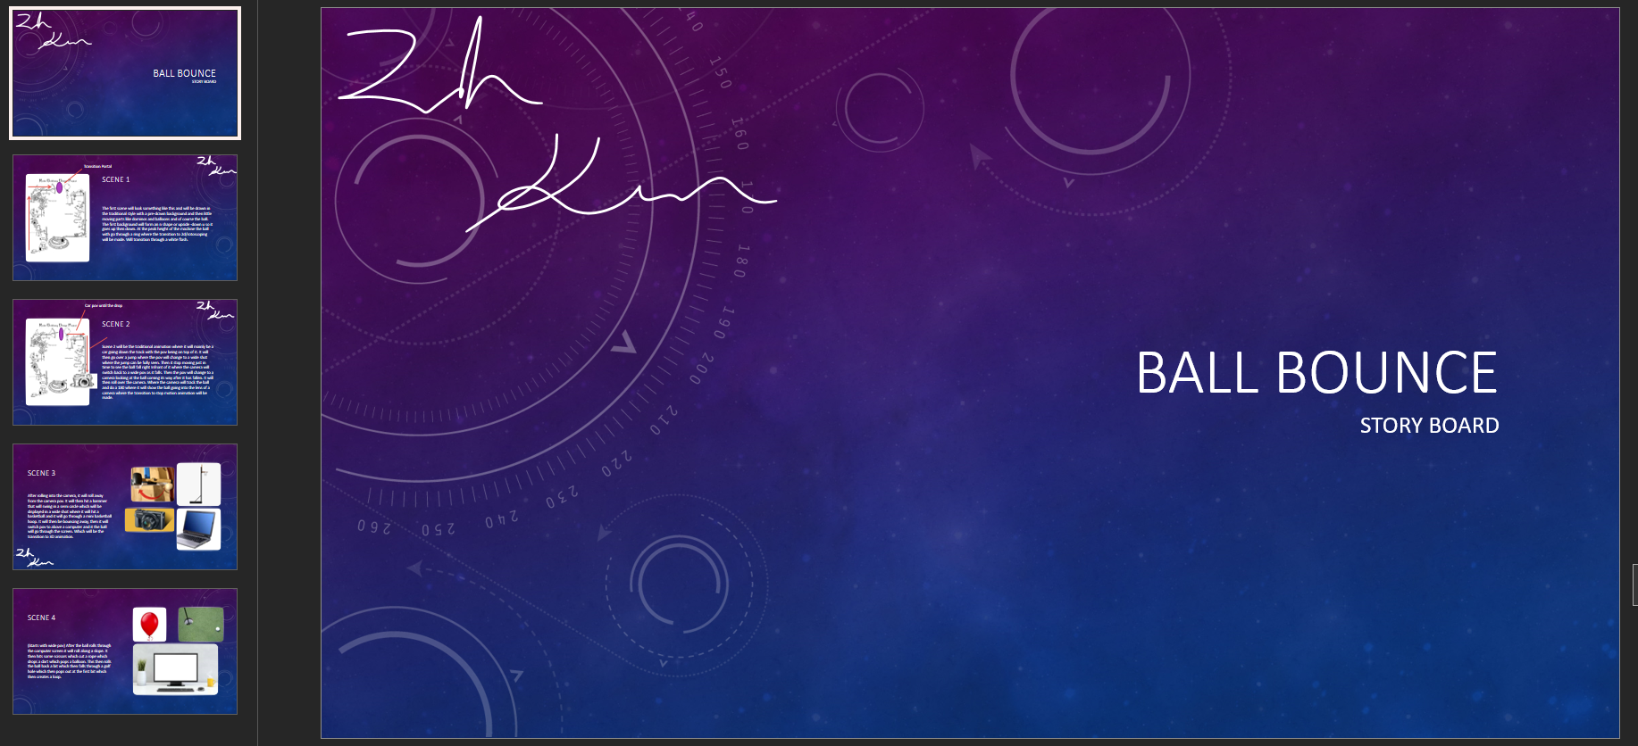

(Storyboarding through slide, it came with a sketch off the backgrounds of each style, but this was lost before photos could be taken)

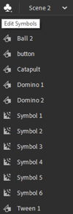(symbols I used)

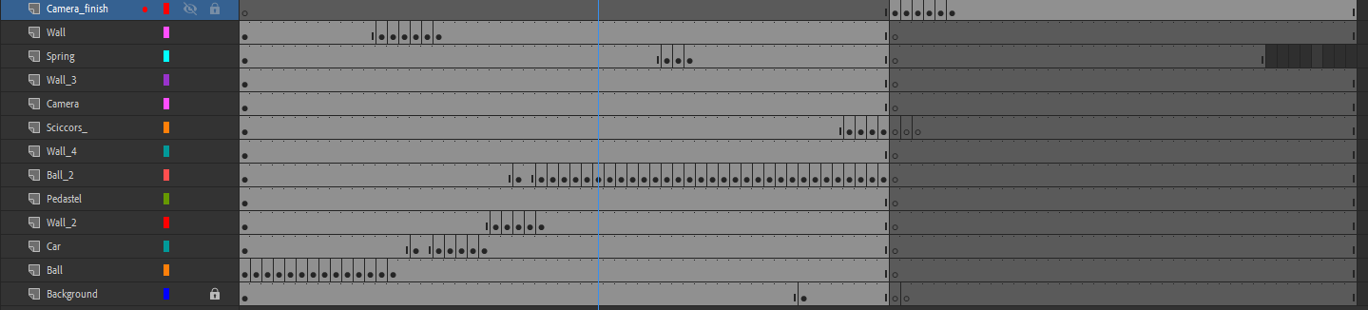(frame layout for traditional animation)

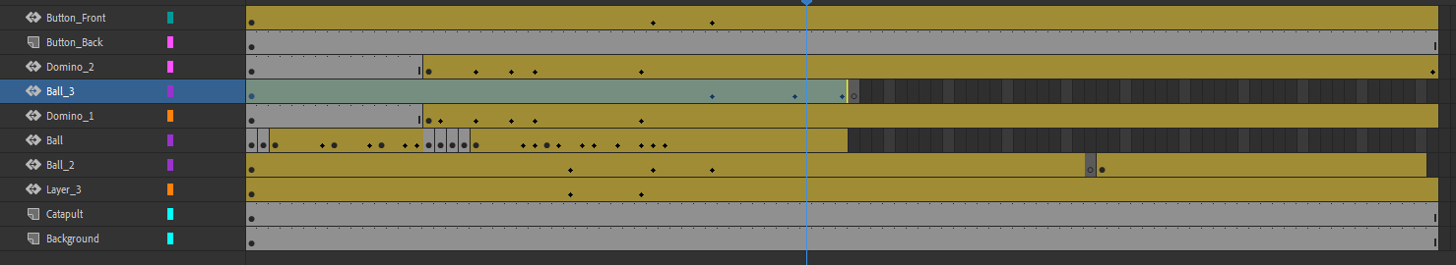(frame layout for 2d Animation)

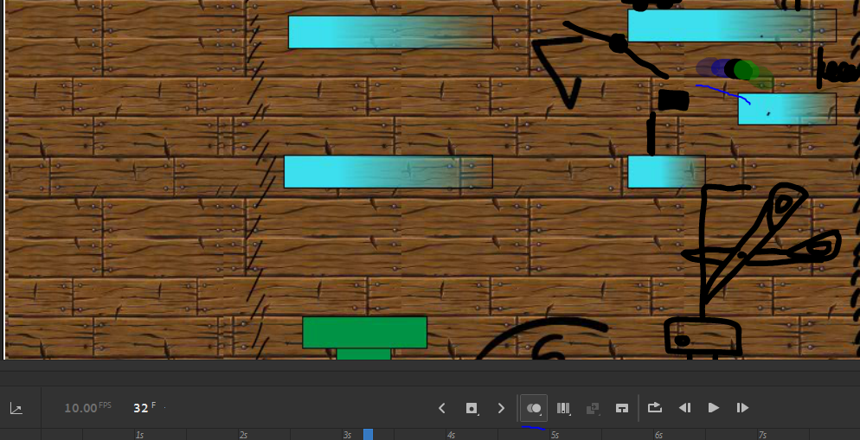

(Onion Skinning In animate) 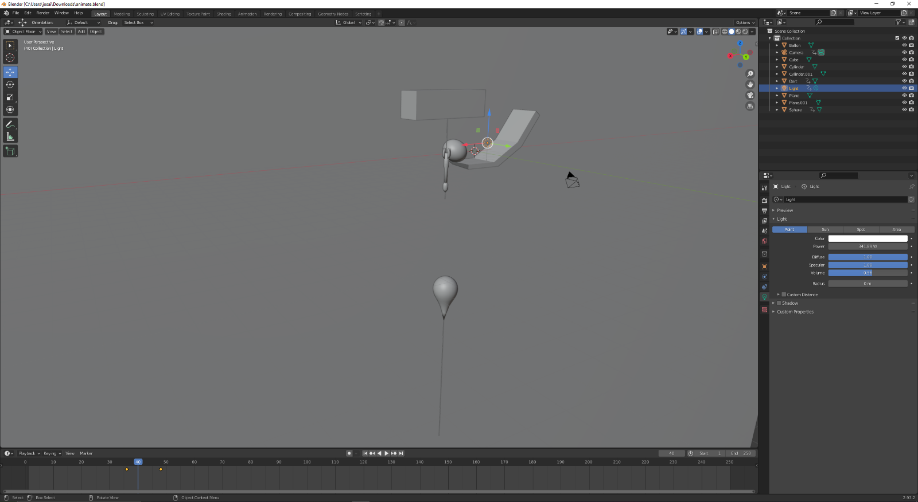

(Screenshot of animation in blender)

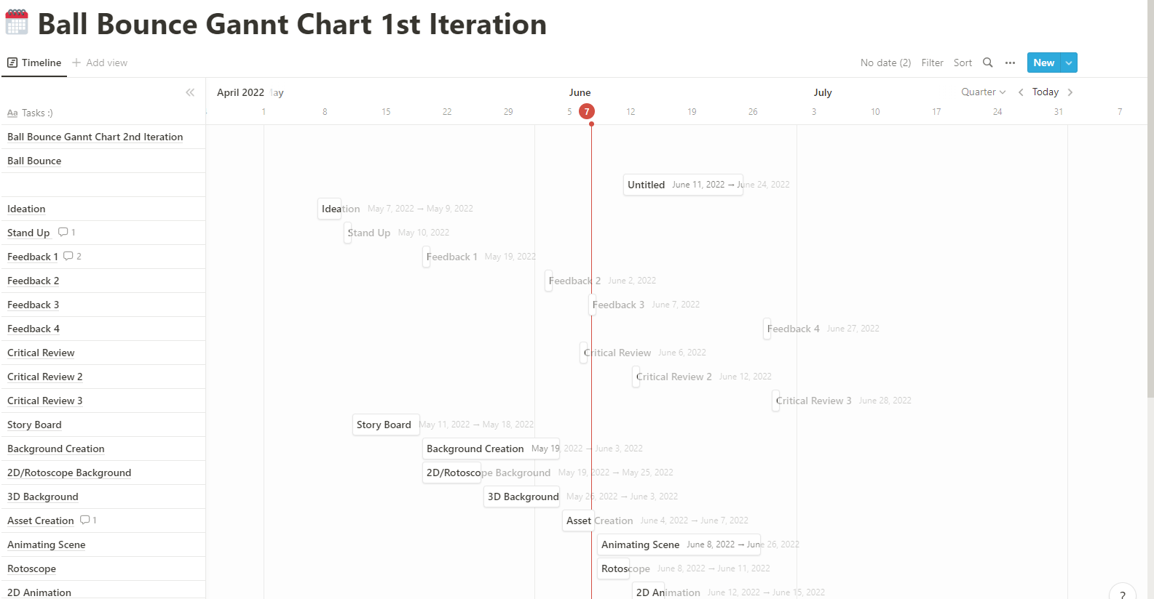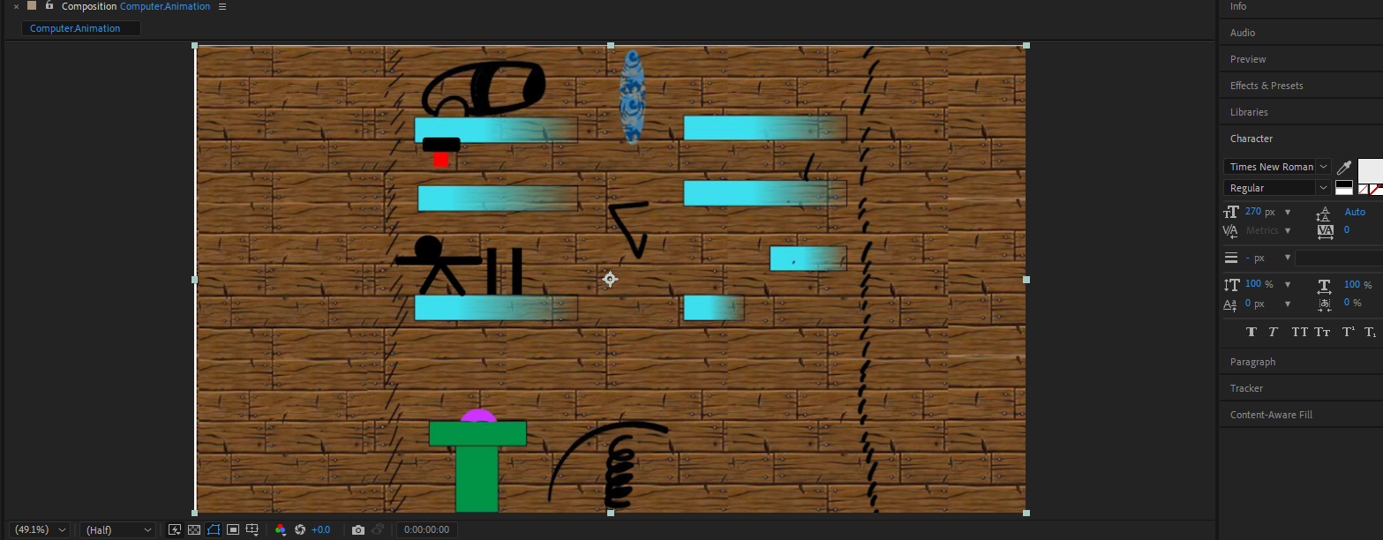

(Screenshot of animation composition in aftereffects)

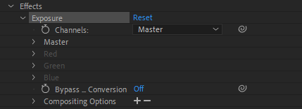

(Using the exposure effect in conjunction with keyframes in aftereffects to create a flashbang style transition between animation styles)

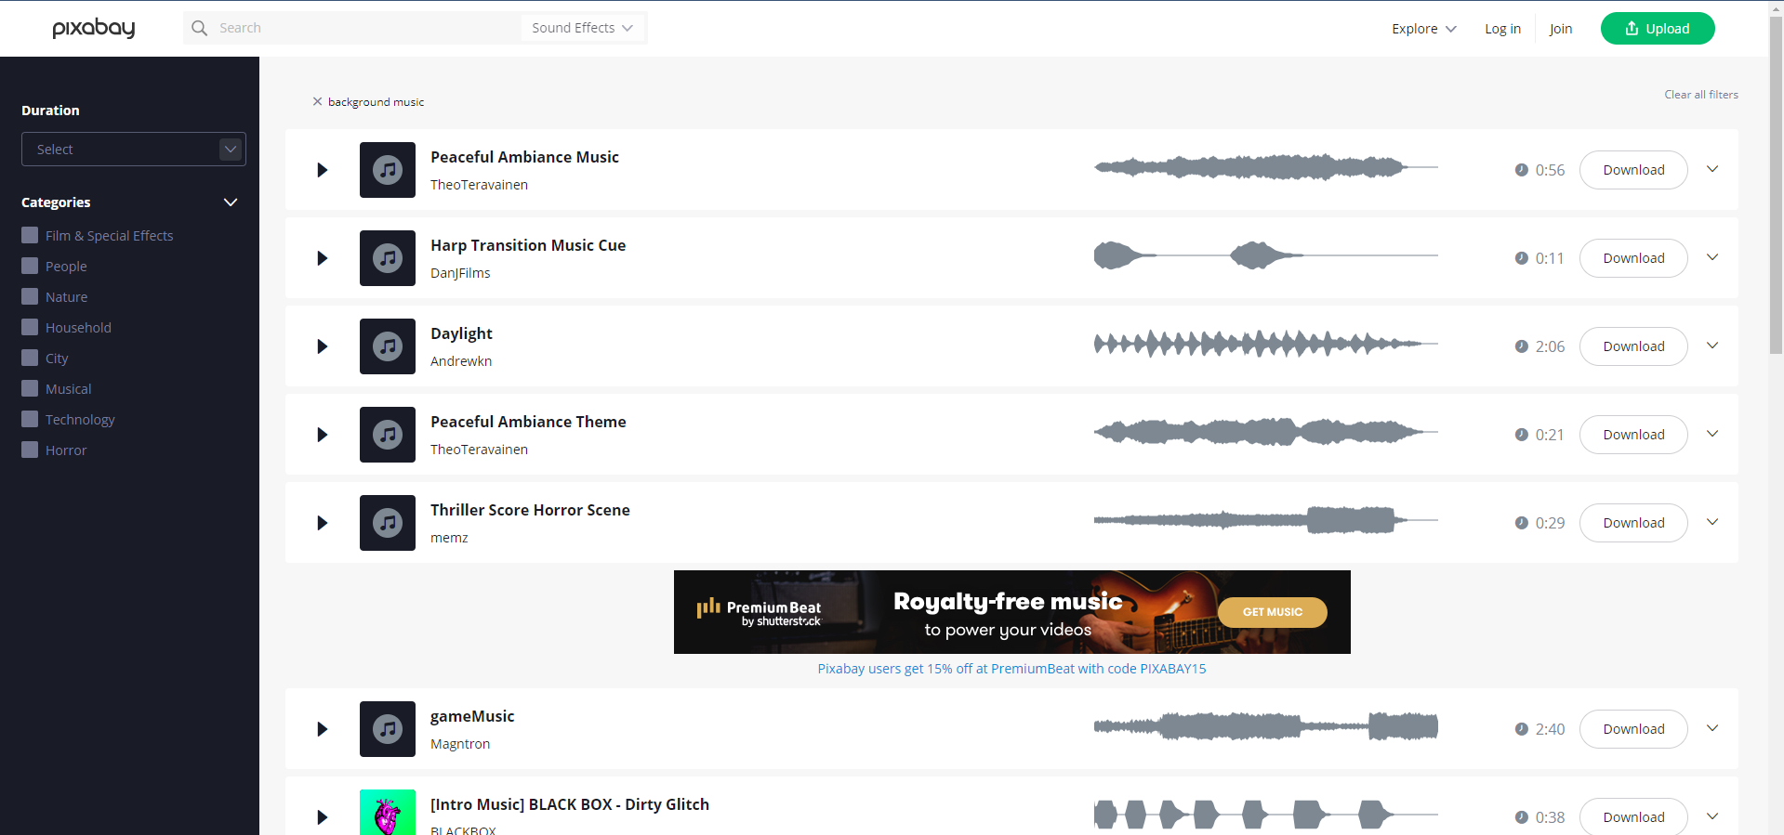(screenshot of me using pixabay as a source of sound which are used in the animation)

* + I used adobe aftereffects instead of premier pro, frankly by accident. I was going to use premier pro to stich the animation together and then aftereffects to add the transitions but opened aftereffects instead and did it in there. This shows how little the 2 software’s were when using them for my project and keeping it all in aftereffects allowed me to save time by not having to export it out of premier pro and then into aftereffects and it laid out my project better this way anyway.
  + I used a shape tween when using animate instead of classic tween or motion tween as shape tween is a combination of the two with other stuff added as well like being able to animate the shape changing colour and changing shape so I could use it when distorting it to add a sense of speed. This helped me mitigate risk as it allowed the computer to fill In the gaps for a smother animation and saved a lot of time.
  + I used onion skinning to save time and better the fluency of the animation because I could see where I came from so it was easier to see where I was going. There weren’t really any other choices I could have used as a replacement, but it helped me reduce risk like a said before through saving time and making the animation more fluid.
  + I used symbols to keep track of all my assets within animate and be able to add shape tweens to them. There wasn’t anything else I could’ve used apart from not using it and it helped me mitigate risk of losing these assets by having them in one place and making them independent from each other.
  + I used pixabay over other sound cloud applications because this was on a browser and also had images, a good selection of sounds with them all being royalty free. Pixabay was very easy to use as I just searched up a sound it would be there for me to download and quickly get into my composition. This helped me mitigate risk by adding sound to the animation making it more lively and easier to experience it also helped me around copy right as all of it is royalty free.